Stroupe
ENGL 5270

Listening Guide Questions: S-Town Episodes 1 and 2

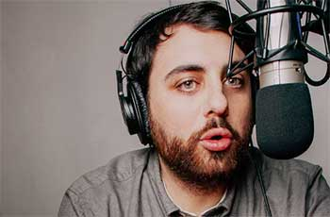

1. Brian Reed. What is Brian Reed (the host/narrator) like: that is, his voice, viewpoint, attitudes, or values? How is he different from the other people we hear?

2. John McLemore. What is John McLemore like : that is, his voice, view point, attitudes, or values? What is his relationship to his hometown? To the host/narrator? To other people featured in the podcast?

3. Place. How does Woodstock, Alabama come across in the podcast? How do the choices made by the producers of the podcast influence your impressions of and perspectives on the town?

4. Effects of Telling-by-Recording. How does the necessity of telling everything with recorded sound affect the story that gets told? Does anything happen off mic? If so, how?

5. Tyler Goodson. Who is Tyler Goodson? What is he like? What is his relationship to the events of the story and to the other people featured in the podcast? Are there other individuals who seem important to the story?

6. The Shape of the Episodes. How are episode 1 and 2 different from one another? How does each one begin and end? How do the two episodes work together to advance a story, create suspense, pose questions, or otherwise suggest the beginning of an arc? Does this podcast have a plot so far?

7. A Story Composed of Real People Speaking. What technical, moral, legal, technical, or narrative problems might arise because this is not an invented story but real people speaking in real time in the real world? Does that affect how Brian Reed and the other producers present the podcast?

8. Craftsmanship. Despite being composed of real people and read events, in what ways are the podcast episodes nonetheless "written" and shaped for effect? What might those intended effects be? How are these effects created? Are these techniques and effects “literary”?

