Stroupe
University of Minnesota Duluth

Voyant Tools Tutorial

YOUR FIRST CORPUS

- If necessary, convert text(s) to machine-readable format:
  - If you have a PDF in which you can't highlight text line by line, for example,
    - use Adobe Acrobat or other software you have
      - With the Document open in Acrobat, choose Document > OCR Text Recognition > Recognize Text Using OCR,
OR
    - An online service like https://onlineocr.net/
      - Suggestions about using online services:
        - Before using them, test the security and privacy of sites or online services with Norton Safe Web at <https://safeweb.norton.com/>.
        - If the online service prompts you to provide personal information, leave it blank or, if required, use inaccurate details. If a working email is necessary, use a secondary address if you have one, or use the service <https://10minutemail.com/> for a temporary email address.
- Copy the text from the PDF to a Word file or .txt file (we'll call this the "source" file from now on)
  - Highlight the text or portions of text you need in the converted PDF file
  - Choose Edit > Copy ("Command+c" on a Mac)
  - In a Word or .txt file, choose Edit > Paste ("Command+v" on a Mac)
- Clean up Your Source File
  - In your Word/.txt source file, remove any matter from your document(s) that you do not want included in your analysis.
(This might include page numbers, front matter, the work's title or author's name on the first page, headers or footers that appear on the printed pages, etc.)

- Go to Voyant Tools at <http://voyant-tools.org/>

- Upload text or texts
  - Copy and paste in the text into Voyant's text field if it's short
OR
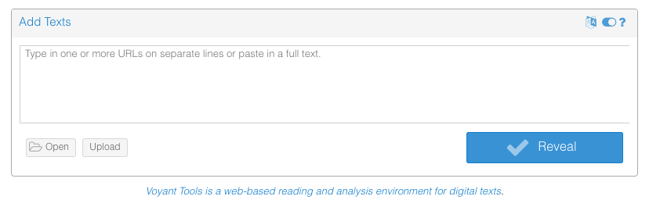
  - Clicking the "Upload" button to upload your source file
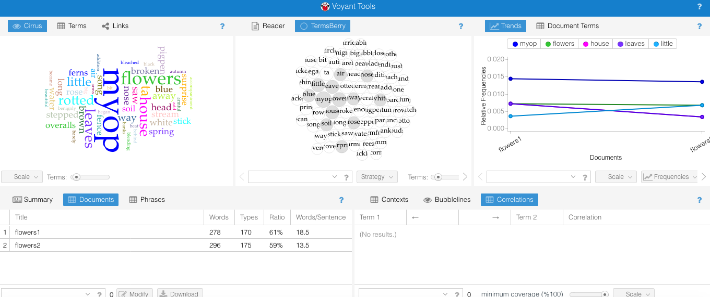
- After uploading and processing, you will see the results of Voyant's analysis on a new page called the "skin"
- Save your corpus
NOTE: Once you have uploaded a text or set of texts into Voyant where it is viewable in a "skin," the text(s) is/are called a "corpus"
  - In the top right corner of the Voyant screen, scroll over the blue band to the left of the "?" until you see a set of icons appear

- Choose the Export icon (square with up arrow) and, in the dialogue box that appears, click "Export"
- The page will re-load in the browser at a dedicated, permanent URL. Bookmark this page so you can return to it later,
OR
copy the URL from the Location Bar at the top of the browser window, and paste it into a document where you can find it later.
- In a new browser tab or browser window, paste in the URL to see if the Voyant skin analyzing your document will load.
- Explore the Tools
  - Using the Tool Index at <http://docs.voyant-tools.org/tools/>,
    - read about different tools that visualize and quantify the text
    - Follow the "more documentation" link for interesting tools you want to try
    - Use the directions for each tool to analyze your text in particular ways.
  - For more tools and explanations, see Voyant's Tools Help site at <http://voyant-tools.org/docs/#!/guide/start>
  - On a sheet of paper, make a list of 3 tools you like (or at least make sense to you)
  - Make another list of tools (or functions of tools) that don't seem to work or do much (to figure out later)
- Export a particular Tool Pane to view enlarged on its own browser page
  - Choose one Tool Pane showing an interesting view of some data
  - In the top right corner of that pane, pass your cursor over the top right corner of that pane to the left of the "?"
  - Choose the "Export" icon (square with arrow) and a new browser tab will open showing just the content of that pane.
  - Bookmark the URL of that page (or copy and paste the URL into a document you keep) to have a permanent copy
- Take a screen shot of a visualization or table of data
  - With the particular tool pane from the previous step open in your browser, take a screen shot.
    - On a Mac, choose Command+Control+Shift+4
    - Your cursor icon will change into a cross-hair
    - Drag diagonally to select the exact portion of the screen you want to capture (this will save the image temporarily on your Mac's clipboard)
    - In a Word file, the file of an image-editing software, or a variety of other image-friendly documents, paste the image in (Command+v).
    - You should see your screen-shot image appear in the document where you can save it

YOUR SECOND CORPUS (MULTIPLE DOCUMENTS)

- Split Your Source File into 2 New Files
  - Copy portions of your original source file on your computer into two new, different files saved on your computer with different file names.
  - We'll call these your "source files."
- Go to a new Voyant Tools start page at <http://voyant-tools.org/>
  - Click the Upload button and--in the dialogue window that appears--navigate to and select both the source files you just created.
(NOTE: On a Mac, you can select multiple files in a dialogue window by holding down the "Command" key as you click with the mouse)
  - With both files selected in the window, click the "Open" button at the bottom right
  - In the Voyant skin that appears next, look in the bottom right of the screen and click the "Documents" button. You should see both our uploaded documents included in the same corpus.
  - Save your new corpus by choosing the Export icon from the extreme upper right of the screen (as you did earlier), and the skin will reload in your browser window.
  - Bookmark or copy and paste the URL for permanent access to this new, multi-document corpus

MORE
See an additional workshop at <http://docs.voyant-tools.org/category/workshops/>

