University of Minnesota Duluth
Stroupe
Starting with Dreamweaver Again (Importing a Site)

1. Open Dreamweaver and set up the workspace for design work.
A. From Dreamweaver’s horizontal menu across the top, choose Window > Workspace Layout > Design

2. Import the site information (a small file ending in .ste) that you previously exported.
A. From Dreamweaver’s horizontal menu across the top, choose Site > Manage Sites
B. In the “Manage Sites” window, click the “Import” button
C. In the “Import Site” window, navigate to the location where you previously saved your site information (a file titled “www.ste”).
D. With “www.ste” select, click the “Open” button.
E. In the “Manage Site” window, click “Done.”

3. Adjust the Files Panel columns, if necessary, to see the complete file names.
A. Look on the right and find the File Panel (click the “Files” tab to bring the Files Panel to the front if necessary)
B. You may find that the columns of the Files Panel conceal the files names as in the screenshot below.
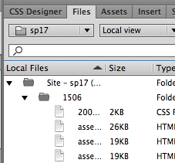

C. With your mouse, drag the tiny vertical line to the right of the “Size” heading to expand the column containing the file names, as seen below.
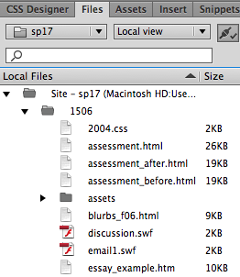

4. Open a page and choose the “Design,” Rather than “Split” View
A. From Dreamweaver’s horizontal menu across the top, choose Window > Workspace Layout > Design
B. In the upper left of the Dreamweaver workspace, be sure the down-down menu is set to “Design” rather than “Live.”
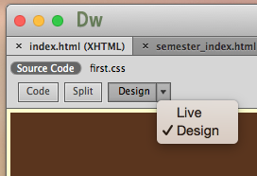

C. If the document appears split between code and visual design, click again on the “Design” option in the drop-down menu box as if it were a button.

