University of Minnesota Duluth
Stroupe
Aggregations in Excel
(Slugging Percentages)

1. Download the Excel file and open it.
A. See the course home page.

2. Make a Clustered Column Chart, including the labels and numbers, just to see what these numbers reveal
A. In the worksheet, drag your cursor to select the cells with labels and numbers.
B. At the top of the workspace, select the “Charts” tab.
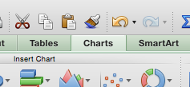
C. From the menu of charts, choose “Column” and, from the fly-out submenu, “Clustered Column.”

3. Reverse the Row/Column arrangement on the chart to enable easier comparisons of players.
A. In the chart, right-click (Option+click) in the middle of the chart
B. From the fly-out menu, choose “Select Data”
C. Click the “Switch Row/Column” button

4. Let’s create a more revealing aggregation (a.k.a. “index”) that allows us to compare the effectiveness of these batters using a single number. This number is a standard baseball statistic called a “slugging percentage” (Total bases/At Bats).

In a new column on the right, create a formula that computes total bases for each player.
A. In the cell to the right of “Home Runs,” type “Total Bases”
B. In the cell below “Total Bases,” enter “=”
C. Next, click the cell in that player’s row containing the number of singles (1B). Right after the = Excel will enter the row and column coordinates for the cell you clicked.
D. Immediately after that row/column coordinate enter a “+”
E. Click the cell in that player’s row containing the number of doubles (2B)
F. Immediately after the coordinates for doubles, type a “*” (which is Excel language for multiplying, the same as an X), and then enter 2 to multiply the number times two bases. What you have should look something like, “=C2+D2*2”
G. Immediately after the formula (leaving no spaces), type a “+”, then click the cell for triples to get Excel to enter that coordinate, then type “*3” to multiply times three bases.
H. Immediately after that row/column coordinate enter a “+” and follow the same process for home runs (*4)
I. You should finish with a formula that looks something like this (the particular coordinates my vary): =C2+D2*2+E2*3+F2*4
G. Without clicking anywhere else or entering any characters or spaces, hit “Return”
H. You should see number of total bases appear calculated in the cell where you typed the formula.
I. Copy the formula to the cells in that column for the other players by doing the following:
1. click the cell with the formula to highlight it (outlined in blue),
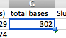
2. hover the cursor over the tiny handle in the bottom right corner of the highlighted cell, and the cursor should turn into a plus sign.
3. Drag the corner of the blue selection box down to include the cells for the other players in that column.
4. You should see the total bases for the other players calculated in their cells.

5. In a new column on the right, create a formula for each player that divides the total bases by the number of at bats, which gives you an aggregation known as the “slugging percentage”
A. In the cell to the right of “Total Bass,” type “Slugging Percentage”
B. In the cell in the first player’s row under “Slugging Percentage,” type “=”
C. Click the cell containing that player’s Total Bases to get Excel to enter the coordinates for that cell.
D. Immediately after the coordinates, type a “/” (this is Excel language for division)
E. Then click the cell for that player containing the At Bats, which enters that coordinate after the / sign. Your formula should look something like this: “=G2/B2”
F. If necessary, you can tell Excel to display the calculation in the three-digit format that is standard in baseball:
1. Highlight the cell so it is selected with a blue outline,
2. From the tabs at the top of the workspace, choose “Home”
3. In the “Number” section of the top menu, find the “Decimal Places” buttons
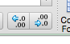
which you can click to increase or decrease the number of decimal places displayed in that cell.
G. As you did with “Total Bases,” copy the formula in the cell “Slugging Percentage” to the cells in that column for the other players: highlight the cell, drag the corner handle down the column to select the additional cells.

6. Delete the old chart, and create a new Clustered Column Chart showing only the names and Slugging Percentages.
A. In the worksheet, select the old chart and hit “Delete.”
B. Select the cells with the players’ names (including the blank cell above them) by pressing on the top cell and dragging down the column and releasing.
C. Holding down the “Command” key, drag down to select the cells containing the label and numbers for the “Slugging Percentage” (Command lets you select non-adjacent cells, columns, or rows).
D. With the two columns selected, go up to the top menu to choose the “Charts” tab.
E. In the menu at the top, choose “Column” and, from the fly-out menu, “Clustered Column.”

7. If needed, change the numerical scale of the x (vertical) axis so it starts at zero, allowing for a true visual comparison of the differences between players.
A. In the chart, right-click (Option+click) on the numbers of the vertical axis.
B. From the fly-out menu, choose “Format Axis.”
C. From the left-hand menu, choose “Scale”
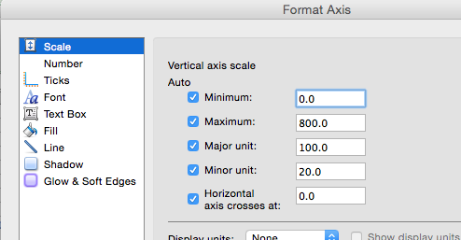

D. In the box beside “Minimum,” enter “0” and click “OK”

8. Save your worksheet to your USB (in your class folder, not your “www” folder)
A. File > Save

