Craig Stroupe | University of Minnesota Duluth
Moving Files to the Web with Dreamweaver MX 2004 (including setting up local and remote sites)

What to Do | How to Do It
- First, on your disk/drive arrange the folders and files in exactly the way you want them to appear in your “www” folder on the server. | On your disk, have a folder called “www” for all your Web stuff.  Inside “www,” have a separate folder for each class you have for which you’ve created Web pages. For instance, in “www” you should have a folder for this class called “5230” and inside that folder another folder called “exercises.”  Inside of “exercises” you’ll have a folder for each exercise you’ve done.
- In Dreamweaver, create a new site called “www.”  You can skip to Step 6 if you’ve already set up the local site today, or if you can import the site’s settings that you exported previously to your disk as a .ste file. | Choose Site > Manage Sites…  In the dialogue box, choose “New” > “Site”  Be sure the “Advanced” tab is selected in the “Site Definition” window (it’s actually easier).
- First, you need to tell Dreamweaver where your “www” folder is on your Zip disk.  - In the “Site Definition” window, call this site “www”.  - Beside “Local Root Folder,” click the tiny folder icon and navigate to the “www” folder on your disk or drive.  Don’t click OK yet! | 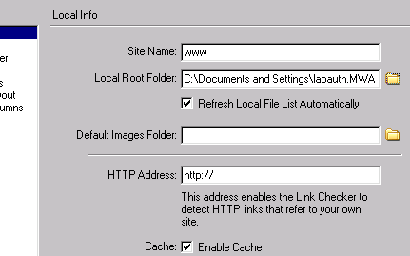
- Next, you need to tell Dreamweaver where your “www” folder is out there on the Web server.  You can skip to Step 11 i f you’ve already set up the “remote info” for your “www” site today.  - Still with the “Site Definition” window open from the previous step, choose “Remote Info” on the left,  - Open the “Access” drop-down menu on the right and choose “FTP” | 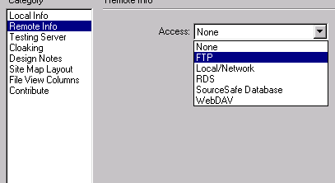

- In the “Remote Info” Window, fill out the FTP information  Once you put in your own Login and Password, rather than mine, click the “Test” button  Unclick the “Save” box so your password isn’t saved on this public computer.  Click okay | 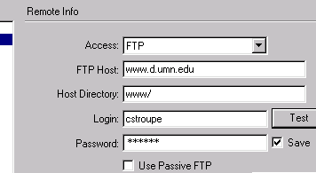
- When you see the “Manage Sites” dialogue box just click “Done”

- In the Site Window on the right, click the “Expand/Collapse” button (it looks like a little opened book on the far right) | 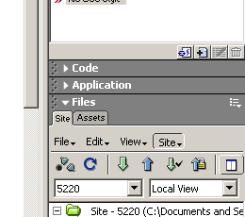
- In the expanded sites window, click the Connect button at the top | 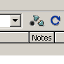
- On the left side (“Remote Site” side), you’ll see a blank if you’ve never uploaded Web pages to your UMD Web space.  If you (or someone) has uploaded files or folders to your Web space before, you’ll see them listed on the left.  Now, upload your “5230” folder to the top level of the “www” folder on the left (that is, not inside of some other folder you see there). | Drag your “5230” folder from the right (local) side of the expanded Sites Window to the left “remote” side of the window.  Be sure to drop the “5230” folder into the top-most “www” folder, and not in some sub folder. If you currently have nothing in your Web space, you’ll just have the empty “www” there. Drop “5230” into that.  You’ll only need to do this whole thing once! After that, you’ll just add new or updated files or folders to the remote site as you add them to your disk’s “www” folder. If you don’t upload them to the Web server, no one will see them but you.  The Golden Rule is to keep the remote “www” folder and the “www” folder on your disk mirror images.
- Check that the pages of the project appear on the Web. | With your Web browser, go to  http://www.d.umn.edu/~youruserid/5230/exercises/index.html. Naturally, you should use your user ID in place of “youruserid.”  Notes:  Since any page called “index.html” is the default page for the folder, you can leave it off the “index.html” from the end of the URL when you’re typing it into the browser.  If your folders and files are arranged or named differently from how I’ve suggested above, the path down through the folders to the page will be different and so your URL should express the steps in that path. .  If the page you want is on the top level of your “www” folder, you won’t have any nested folder names in the path, and the URL will be http://www.d.umn.edu/~youruserid/pagename.html.
- Export your site information to your “nonwww 5230” folder so you can “import” them later, saving you the trouble of setting up this “www” site again.  This step wouldn’t be necessary if you were working on your own computer, rather than on a lab computer that gets “reimaged” every night. | Site > Manage Sites  Choose the “Export” button  Navigate to the “nonwww 5230” folder your Zip disk or drive and save the site settings file (.ste) on the top level of that folder.  When you come back next time, you can  - Choose Site > Manage Sites > Import,  - Navigate to that .ste file containing your site settings, and  Dreamweaver will then remember all your settings back without your having to recreate the site!

