Plato

Artistotle

Arnold

Wilde

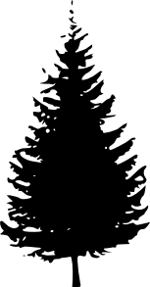
Benjamin

