Craig Stroupe
REALISM | AESTHETICISM
presents “large and detailed canvases depicting a specified historical period” (including sometimes the present) (Cobley 85) | “An artist should create beautiful things…to rouse, to startle [the human spirit] to a life of constant and eager observation…. To burn always with this hard, gemlike flame, to maintain this ecstasy, is success in life” (Wilde vii; Pater).
focuses on a varied society of national scale consolidated from “disparate [local] elements” (Eagleton qtd. in Cobley 88) | “All art constantly aspires towards the condition of music. For while in all other kinds of art it is possible to distinguish the [subject] matter from the form…yet it is the constant effort of art to obliterate [the distinction]” (Pater)
sees “localized, personal problems” in “big political and historical” terms (Cobley 88) | No artist desires to prove anything” (Wilde vii).
focuses on the material existence shared by a “knowable community” (Cobley 80) | “It is the spectator, and not life, that art really mirrors...[a spectator who is] a being with myriad lives and myriad sensations, a complex multiform creature” (Wilde 104)” (Wilde viii, 104)
often assumes “that there is one, authoritative meaning” which is frequently achieved through an “omniscient” narrative point of view presenting social facts and “common sense” judgments (Cobley 95, 91) | It is “[n]ot the fruit of experience, but experience itself…for that moment only” that expresses the meaning of a work of art” (Pater). “There is no such thing as a moral or immoral book. Books are well written, or badly written, that is all” (Wilde vii).
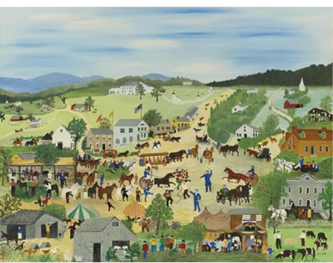 | 