WRIT 1506
Stroupe
The Cathedral and the Book
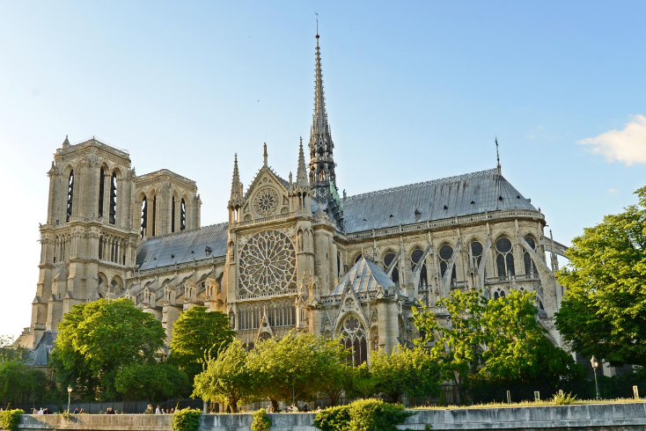

In his novel Notre Dame de Paris, 1482, the French writer Victor Hugo (1802-1885) imagines the following scene from a moment in history about a generation after the invention of print in about 1440:

Opening the window of his cell, [the archdeacon] pointed to the immense church of Notre Dame, which, with its twin towers, stone walls, and monstrous cupola forming a black silhouette against the starry sky, resembled an enormous two-headed sphinx seated in the middle of the city.
The archdeacon pondered the giant edifice for a few moments in silence, then with a sigh he stretched his right hand toward the printed book that lay open on his table and his left hand toward Notre Dame and turned a sad eye from the book to the church.
"Alas!" he said, "This will destroy that." (197)

Modern-day scholar Jay David Bolter comments:
In Victor Hugo's [1831] novel…the priest remarked "Ceci tuera cela": this book will destroy that building. He meant not only that printing and literacy would undermine the authority of the church but also that "human thought...would change its mode of expression, that the principal idea of each generation would no longer write itself with the same material and in the same way, that the book of stone, so solid and durable, would give place to the book made of paper, yet more solid and durable" (199). The medieval cathedral crowded with statues and stained glass was both a symbol of Christian authority and a repository of medieval knowledge (moral knowledge about the world and the human condition). The cathedral was a library to be read by the religious, who walked through its aisles looking up at the scenes of the Bible, the images of saints, allegorical figures of virtue and vice, visions of heaven and hell. (See The Art of Memory by Frances Yates, 1966, p. 124.) Of course, the printed book did not eradicate the encyclopedia in stone; it did not even eradicate the medieval art of writing by hand. People continued to contemplate their religious tradition in cathedrals, and they continued to communicate with pen and paper for many purposes. But printing did displace handwriting: the printed book became the most highly valued form of writing. And printing certainly helped to displace the medieval organization and expression of knowledge. As Elizabeth Eisenstein has shown, the printing press has been perhaps the most important tool of the modern scientist. (See The Printing Press as an Agent of Change by Elizabeth Eisenstein, 1979, especially vol. 2, pp. 520ff.) (1-2)

Work Cited
Bolter, Jay David. Writing Space: Computers, Hypertext, and the Remediation of Print.
2nd ed. Hillsdale, NJ: Lawrence Erlbaum, 2001.

