|  |  |  |  |  |
| --- | --- | --- | --- | --- |
| |  |  | | --- | --- | | **LIFE**  Born on October 16, 1854 in Dublin, Ireland, author, playwright and poet Oscar Wilde was a popular author, playwright, and poet in late Victorian England, known for his brilliant wit, flamboyant style, and infamous imprisonment for homosexuality.  After graduating from school in Dublin, Wilde attended Oxford University where he came under the influences of John Ruskin, a critic, writer, and professor, and Walter Pater, a critic and essayist whose *Studies in the History of The Renaissance* legitimized Wilde's nascent ideas on art and individualism. After graduating from Oxford University, Wilde lectured as a poet, art critic and a leading proponent of the principles of aestheticism. In 1882, Wilde traveled from London to New York City to embark on an American lecture tour, for which he delivered a staggering 140 lectures in just nine months.  Back in London he made an advantageous marriage to Constance Lloyd, an heiress, sired two boys and gravitated to the centre of society’s “swirl and whirl”, borne on his gift for talk and his burgeoning talent as a playwright.  Beginning in 1888, while he was still serving as editor of the magazine *Lady's World*, Wilde entered a seven-year period of furious creativity, during which he produced nearly all of his great literary works. In 1891, he published *The Picture of Dorian Gray,* his only novel which was panned as immoral by Victorian critics, but is now considered one of his most notable works. As a dramatist, many of Wilde’s plays were well received including his satirical comedies *Lady Windermere's Fan* (1892), *A Woman of No Importance* (1893), *An Ideal Husband* (1895) and *The Importance of Being Earnest* (1895), his most famous play.  Around the same time that he was enjoying his greatest literary success, Wilde commenced an affair with a young man named Lord Alfred Douglas. On February 18, 1895, Douglas's father, the Marquis of Queensberry, who had gotten wind of the affair, left a calling card at Wilde's club addressed to "Oscar Wilde: Posing Somdomite," a misspelling of sodomite. Although Wilde's homosexuality was something of an open secret, he was so outraged by Queensberry's note that he sued him for libel. The decision ruined his life.  When the trial began in March, Queensberry and his lawyers presented evidence of Wilde's homosexuality—homoerotic passages from his literary works, as well as his love letters to Douglas—that quickly resulted in the dismissal of Wilde's libel case and his arrest on charges of "gross indecency." Wilde was convicted on May 25, 1895 and sentenced to two years in prison. Wilde emerged from prison in 1897, physically depleted, emotionally exhausted. In poverty, he died of meningitis in November 1900 at the age of 46.  Wilde’s last words lying on his deathbed in a Paris bedroom: "The wallpaper and I are fighting a duel to the death. One or the other of us has to go."    Establishing herself as a writer in her hometown, in 1964 she gained recognition for her essay “Notes on Camp.” She published four novels and nine works of non-fiction, and directed four feature-length films. She died in 2004 in New York City.  **KEY IDEAS IN ONG’S *ORALITY AND LITERACY***  How the psychologies of sight and sound differ  Consciousness  Writing as a technology  Language and its influence on self and society  Media in history  How knowing the ancient world helps us understand the present and future | **QUESTIONS**  ⎯ In *The Picture of Dorian Gray*, what opinions are expressed about the relationship of life and art (or representation)?  — How do we decide what Wilde is saying in the novel about the relationship of life and art? about how fictional representation says anything at all?  **COMMENTARIES ON WILDE AND  *THE PICTURE OF DORIAN GRAY***  “The manuscript [of *Dorian Gray*] shows the workings of Wilde’s mind as he was writing it. He’d reached a point when he was in danger of becoming respectable and conventional – in 1889 he was married with 2.4 children, living in slightly bohemian Chelsea. What he’s doing with *Dorian Gray* is treading a very fine line.... I think his whole purpose in writing this book was to break out of the Victorian mould of what Lady Bracknell called the ‘three-volume novel of more than usually revolting sentimentality.’ He does not want, at this juncture of his life, to toe the line and respect social conventions. His purpose is to shock and tweak the noses of the establishment – but he’s intelligent enough to know that if he goes too far, there is going to be trouble.”  - Merlin Holland, Wilde's 72-year-old grandson writing in the   introduction to the 2018 facsimile edition of *The Picture of*  *Dorian Gray*  “a poisonous book, the atmosphere of which is heavy with the mephitic odours of moral and spiritual putrefaction[, written] for outlawed noblemen and perverted telegraph boys”  – The *Scots* *Observer* in July 1890, responding to the first  serialization of “The Picture of Dorian Gray” in *Lippincott’s*  *Magazine* | |  |  | |

**Oscar Wilde**

  *Over a century on, Oscar Wilde continues to hypnotize us. The work, though distinctly uneven, is filled with intellectual provocation and delicious fantasy, and studded with scintillation, but it is the life – those action-packed 46 years with their almost Greek trajectory of catastrophe, rapid fall and pitiful resolution – that has marked him out as one of the great symbolic figures of western civilization. We keep coming back to him, trying to make sense of his actions. Was he simply a victim of society? Were there inherent flaws in him that governed, or failed to govern, his actions? What sort of man, indeed, was he? In person, he beguiled many of his contemporaries, but his behaviour was by no means always admirable; often it was barely intelligible. He remains a mystery, his motives as puzzling as Hamlet’s.*

*- Simon Callow, The Guardian 1/15/16*

***“***"I have put all my genius into my life. I have only put my talents into my work."   
 - Oscar Wilde in a letter to Andre Gide

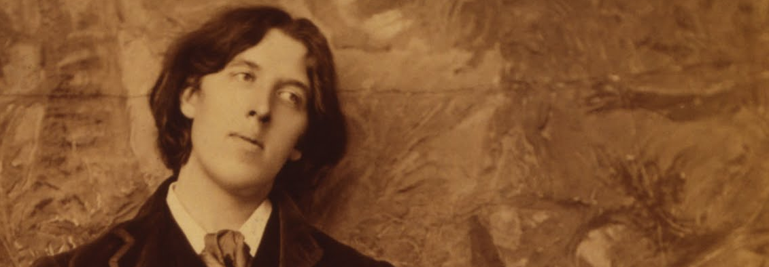

WRIT 1506 | Stroupe