Craig Stroupe
WRIT 1506

Modernism

A style of art and culture characterized by:

- the multifaceted nature of human consciousness, the unconscious, and identity (149, 150)

- a backlash against previous beliefs and certainties; an imperative, as poet Ezra Pound urged, to “make it new,” and to “see differently” (149, 170).

- an isolated, alienated, but “authentic” self who is skeptical of industrialization, capitalism, and “the crowd” (149-150)

- The use of subjective point(s) of view(s) in narrative and art (149)

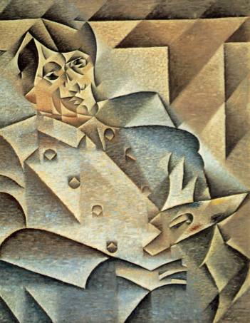
Piccaso
by Juan Gris

