Stroupe
WRIT 1506
Modernism
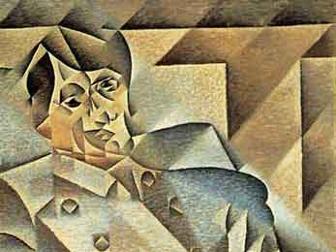
Juan Gris, “Picasso” 1912, as example of the Cubist style of Modernist art

Dates as Current Style: 1900 - Present

“Make It New.” – Ezra Pound 1935

“On or about December 1910, human character changed.” - Virginia Woolf, “Mr. Bennet and Mrs. Brown.” 1924

“I mistrust all frank and simple people, especially when their stories hold together.” - Ernest Hemingway (as narrator), The Sun Also Rises. 1926.

Characteristics  - Belief in the nuance of psychological experience and the multiplicity or “fragmentation” of self (Cobley 113)—in contrast to the possibility of a stable, unified, rationalistic viewpoint or identity posed by previous -isms.  - Rejection of the past as a guide for solving contemporary problems or representing modern experience.  - Skepticism toward mass culture and social institutions, which are contrasted to the authenticity of a reflexive self which is “closed, autonomous, antagonistic” and often alienated (Cobley 135)  - Distrust of official truths or communal, common-sense assumptions.  - Recognition of the primary role of the unconscious in identify and the experience of life (Freudian repression, for example): “the human ego is not even master of its own house” (Cobley 137) | Causes and Conditions (20C)  - expansion of society to a vaster scale: “industrial acceleration” (qtd. in Cobley 136), globalization, economic competition, imperialism, and world war  - rise of mass politics conducted through media and the techniques of designed public spectacles, propaganda, public relations, etc.  - the “imperialist” phase of capitalist development resulting from growth in the scale of economic activities beyond national boundaries and politics (Eagleton qtd. in Cobley 88).  - a reaction against realist styles, which were seen as inauthentically objective, politically uncritical, and psychologically unaware.  - rationalization of life through the increasing influence of science and technological standardization: psychology, economics, corporatization, media networks, surveillance, etc.

