WRIT 1506
Stroupe
Six Characteristics of Postmodernity
(RDHFMI)
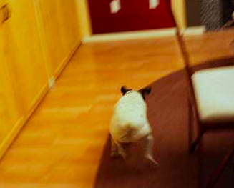
Postmodernity is a “late” phase of modernity (or capitalism) characterized by

R. a “rupturing” of the "reality/media” border with a resulting loss of faith in the possibility of “innocence” and unself-conscious belief (Cobley 156, 166, 180)

D. a “depthless” media environment self-consciously emphasizing the “play of signs” on surfaces in a realm of “simulation” and simulacrum (Baudrillard qtd. in Cobley 171): representations or “signs take on value not because they refer to real, material things, but because they refer only to each other” (Cobley 171).

H. a collapse of hierarchies: the blurring of once-significant distinctions between the real and the simulated, history and narrative, the personal and the public, the serious and the banal, the extraordinary and ordinary, the artistic and commercial, the spiritual and the carnal, etc. (161-162, 172).

F. a prevalence of fragmented, discontinuous forms of representation: rather than following the logic of “closure” (the beginning/middle/ending of a book or movie), we have the formless logic of "flow" (Williams qtd. in Cobley 176-77)

M. a weakening of traditional, “legitimizing” “metanarratives" in favor of “’little, local narratives of personal pleasures, identity, and circumstances" (Lyotard calls it an “incredulity toward metanarratives”) (Cobley 169-170).

I. a prevailing attitude of irony and self-consciousness. To use Paul Cobley’s example: “As Barbara Cartland would put it, I love you madly” (Eco qtd. in Cobley 157).

