Stroupe/ WRIT 1506
Postmodernism
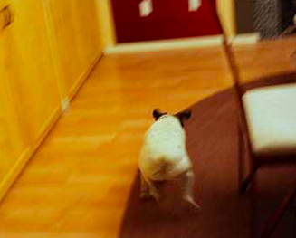

Dates as Current Style: 1940s – Present

“The point is that we are within the culture of postmodernism to the point where its facile repudiation is as impossible as any equally facile celebration of it…. Ideological judgment on postmodernism today necessarily implies, one would think, a judgment on ourselves as well as on the artifacts in question.”
– Fredric Jameson, “The Politics of Theory” (1984)

“[S]hall I spend much of your time pointing out the degree to which televisual values influence the contemporary mood of jaded weltschmerz, self-mocking materialism, blank indifference, and the delusion that cynicism and naïveté are mutually exclusive? “
- David Foster Wallace, A Supposedly Fun Thing That I’ll Never Do Again: Essays and Arguments (1997)

“[W]hat exactly is postmodernism, except modernism without the anxiety?” – Jonathan Lethem, “The Ecstasy in Influence,” (2007)

Characteristics (R.D.H.F.M.I.)  Mnemonic nonsense phrase to remember characteristics: “Real Dogs Have Fun, Generally Inside”  - a “rupturing’’ of the "reality/media” border  - a “depthless” media environment self-consciously emphasizing the “play of signs” in a realm of “simulation” and “simulacrum”  - a collapse of hierarchies: the blurring of once-significant distinctions between the real and the simulated, history and narrative, the personal and the public, the serious and the banal, etc.  - a prevalence of fragmented, discontinuous forms of representation: “flow”  - a weakening of traditional, “legitimizing” “Grand Narratives” in favor of “’little, local narratives of personal pleasures, identity, and circumstances"  - a prevailing attitude of irony and self-consciousness. | Causes and Conditions (20C)  - decline in mass production in favor of flexible specialization.  - rise of information and service industries over traditional industrial manufacture.  - economic and social emphasis on consumption rather than production.  - dissolution of traditional, class-based politics into politics center on “identities.”  - development of communication technologies which serve to shrink distances and make representation more accessible.

