Stroupe
WRIT 1506
Realism
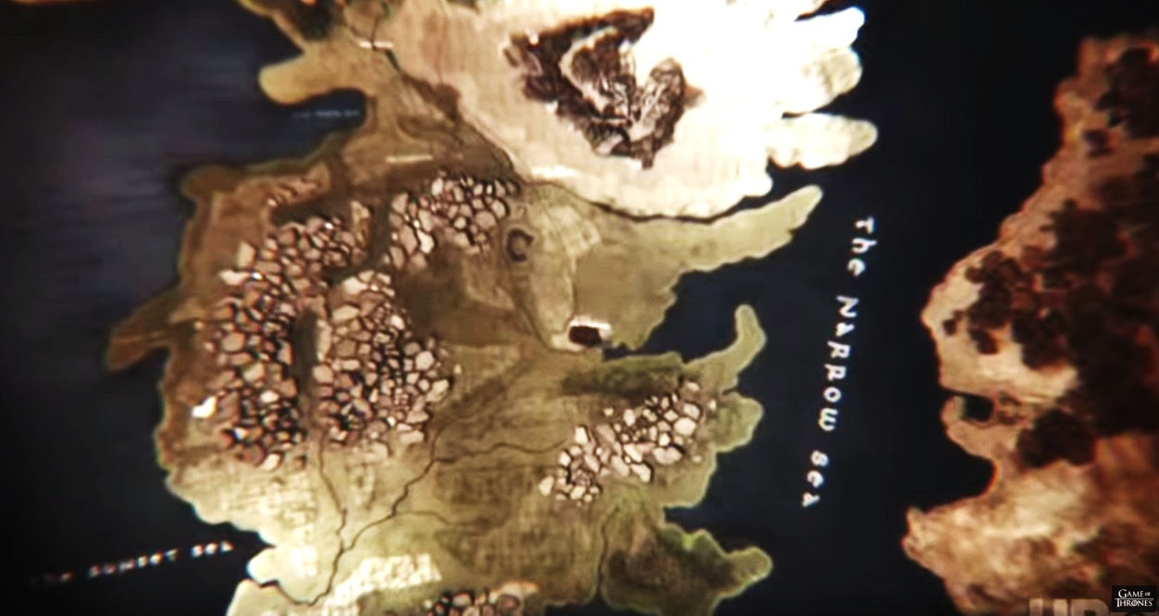
Dates as Current Style: 1850 – 1940s (Residual Thereafter)

"To-day is the day of the novel. In no other day and by no other vehicle is contemporaneous life so adequately expressed; and the critics of the twenty-second century, reviewing our times, striving to reconstruct our civilization, will look not to the painters, not to the architects for dramatists, but to the novelists to find our idiosyncrasy.” - Frank Norris (The Responsibilities of the Novelist [1903] 194)

“It remained for realism to assert that fidelity to experience and probability of motive are essential conditions of a great imaginative literature.” - William Dean Howells (Criticism and Fiction [1891] 15)

Characteristics  - presents “large and detailed canvases depicting a specified historical period,” including possibility the present (Cobley 85)  - focuses on a varied and interconnected society of national scale consolidated from “disparate [local] elements,” (Cobley 88)  - addresses “broad political” and historical issues in the form of…narrative[s] about people in…highly localized situation[s]” (Cobley 87)  - focuses on a material and social existence shared by a “knowable community” (Eagleton qtd. in Cobley 80)  - often assumes “that there is one, authoritative meaning” which is frequently achieved through an “omniscient” narrative point of view presenting social facts and “common sense” judgments (Cobley 95, 91) | Causes and Conditions (l19C)  - Improved transportation and communication in the nineteenth century expands awareness of an extensive, complex, and “networked” world, producing a more nationalized—and less local—awareness and identity.  - Industrialization leads to more division of labor, greater differences between rich and poor, and to the felt need by artists and writers to represent the diversity of lifestyles and economic conditions within a “knowable” and coherent whole (Eagleton’s “corporalist phase of capitalist development qtd in Colbey 88).  - Increased circulation of books, magazines, and newspapers exposes readers to more varied opinions and styles, producing a need to establish authority by finding an ostensibly objective and universal means of representation.  - Increasing influence of science in all professions, including the arts.  - Reaction against romantic styles of representation, identity, and consciousness (from e19C).

