Stroupe

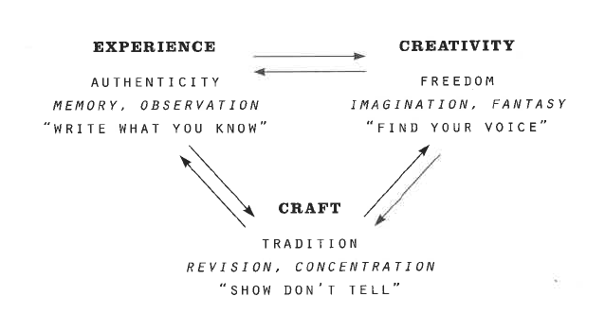University of Minnesota Duluth

3 Values of Creative Writing (Mark McGurl)

In his book *The Program Era: Postwar Fiction and the Rise of Creative Writing* (2009), Mark McGurl examines how creative writing has been defined and institutionalized in American universities in the last 100 years. He analyzes how writing programs developed around three core values, which he visualizes with the diagram above. “The values of experience, creativity, and craft” he writes, commenting on this illustration, “can be understood as the psychic and symbolic resources upon which a writer draws in the act of writing, and here they are supplied with the pedagogical imperatives with which they are commonly associated….

“To write ‘from **experience’** is either to plumb the depths of memory or to engage in quasi-journalistic reportage; in either case the fiction so created will (in theory) have the ring of authenticity….

“To be ‘**creative’** in one’s writing is, by contrast, to imagine the world anew, ‘improving’ upon experience so that it makes for a good story, part of whose excitement will stem from the sense that ‘anything can happen’ in the freedom of fictional worlds….

“**Craft**—also called ‘technique’—adds the elements of acquired skill and mental effort to the process, and is strongly associated with professional pride and the lessons or ‘lore’ of literary tradition. The imperative to ‘show, don’t tell’ is, in turn, strongly associated with the disciplining of the ‘natural’ impulse to express oneself as a self, that is, with the classically modernist value of ‘impersonality.’” (McGurl 18, 23) s

McGurl unpacks these ideas in two more diagrams below. The left-hand illustration further explains what he means by “experience.” The right-hand diagram considers how genre fiction (as opposed to more artistic “literary” fiction) fits into his discussion of “craft.”

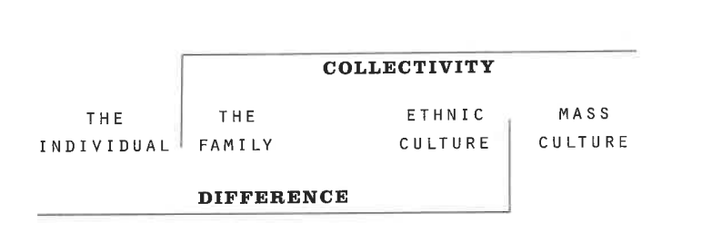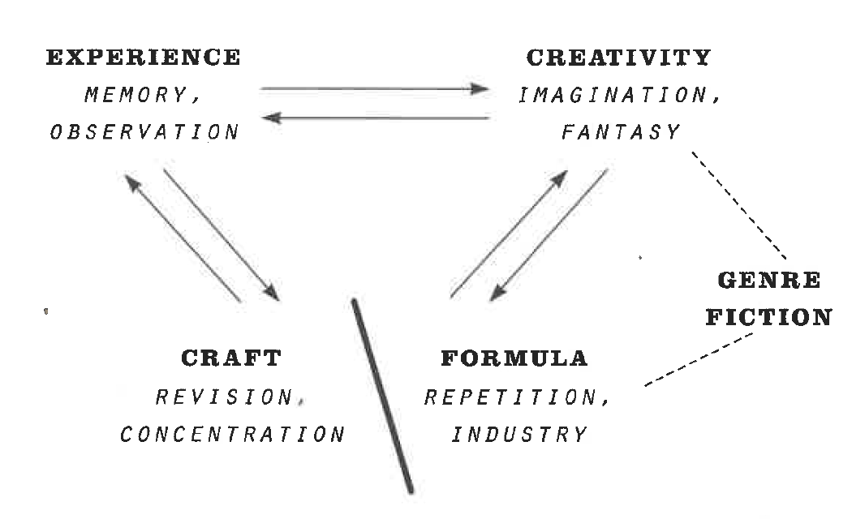

Here, McGurl visualizes how “experience” is simultaneously individual and “collective.” In this way, creative writing presents a world that is both individualistically unique and yet widely recognizable to audiences throughout society. (124)

McGurl adapts his diagram from above to account for the conventions of commercial genre fiction (for example, horror, romance, or fantasy genres) by equating the “formulas” or market expectations imposed by these genres to the principles of Modernist craft. (103)