WRIT 4250

Stroupe

**Sample Steps, Rules, and Guidelines for a**

**Social Creativity Project**

**Sad Chairs**

**The Cruel World of America's Abandoned Chairs**

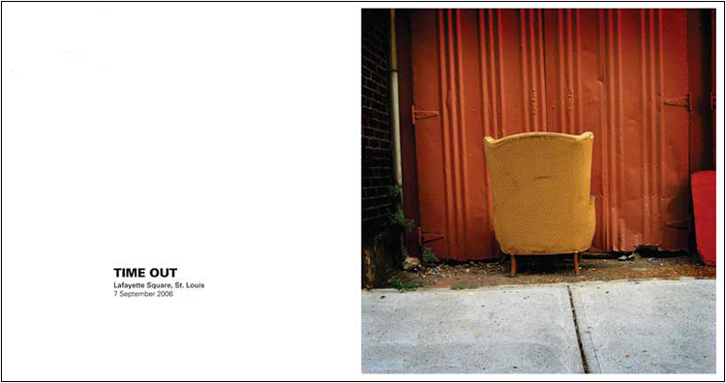

1. Find an abandoned, abused, forgotten, or oddly-placed chair somewhere in the United States
2. Photograph the chair to emphasize the incongruity of its context: that is, its unusual location, the abnormality of the objects around it, its peculiar (mis)match with its setting or background, etc.
3. As you’re taking the photograph, consider ways that you might use choices of background, distance, camera angle, lighting, framing, etc. **to suggest a human situation or emotion**
4. Take several different shots to give you various options
5. At your computer, choose your most suggestive shot
6. Write a 1-5 word caption for that image that **implies--rather than simply explaining or naming--the human situation or emotion** you imagined
7. Using software, scale and crop the image to make the image 380 pixels by 380 pixels square, and to emphasize the emotion you want to convey.
8. Using software, compose chair image in the right half of a white page that is 750 pixels wide and 398 pixels tall, with a thin, even margin at the top, right, and bottom.
9. Centered in the blank space on the left side of the page, compose your caption: all caps; Arial Black, 14-point font; three-quarters of the way down the page.
10. Beneath the caption--aligned with it and justified left--compose the location and date of the photograph in 9-point Arial font, capitalizing only proper names and months.
11. Save and submit the image as a .jpg.