WRIT 4260/5260
Stroupe
Sample Paragraphs from a
“Cultural Work of an Image” Essay

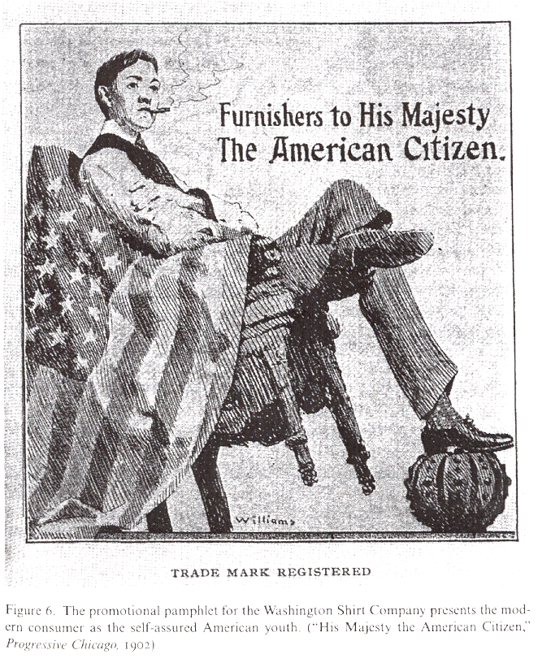

1. FIRST HALF OF PARAGRAPH 1: INTRODUCTION, CONTEXT, AND CULTURAL WORK
“One dares to be young in this day and age,” wrote Margaret Anderson in the 1910s, “because the potentiality of youth has been discovered, and on every side tribute is being paid to it” (qtd. in Morrison 137). Editor of the modernist magazine The Little Review in Chicago, Anderson expresses a cultural attitude toward adolescence that became dominant in the early years of the twentieth century. With the rise of the industrial economy at the end of the nineteenth century, many people, especially adolescents who would otherwise have spent their lives farming, migrated to the cities looking for work and a new way of life. With this influx of young workers and consumers, a new “youth culture” began to emerge (Morrison 137). Many writers such as G. Stanley Hall wrote admiringly of adolescence and its significance to…

2. SAMPLE PARAGRAPH: CLOSE READING USING TUFTE
The spectacle of a young man sitting on a flag while propping himself up on a crown invokes much cultural encoding, an extension of Edward Tufte’s idea of encoding in colors scales in Visual Explanations (13). Cultural codes are symbols in images that people can easily recognize and make connections with. In this image there are two specific cultural codes: the flag and the crown. Both of these objects are well-known symbols of established authority and tradition. However, the way they are being used in this image gives them new meaning. The fact that the young man is casually sitting on the flag and resting his foot on the crown gives one the sense that he lacks the traditional respect usually given these symbols. This irreverence—combined with the fact that he is leaning back in his chair, what all young men are told not to do by their elders—conveys a sense of rebelliousness. The subject’s self assurance, which is apparent in his posture and facial expression as he sits on the flag and props himself up on the crown, makes these items unimportant compared to him. In the image, he is the authority while the flag and crown are his subjects. As a symbol of leisure, comfort, and sophistication at the time this image was created and published, the cigarette suggests the youth’s confidence with this authority. In this way, the cultural encoding of the image expresses the power of youth prevalent in the modernist era.

3. SAMPLE PARAGRAPH: CLOSE READING USING SONTAG
The verbal and visual composition of the Washington Shirt ad conflates two very different identities⎯the citizen and the consumer⎯and in doing so presumes to erase the distinctions between civic obligations and personal desire. In On Photography, Susan Sontag characterizes this distinction between moral feelings and desire as being unambiguously divergent: images, she observes,
can abet desire in the most direct, utilitarian way…. Desire has no history⎯at least, it is experienced in each instance as all foreground, immediacy…. But moral feelings are embedded in history, whose personae are concrete…. Thus, almost opposite rules hold true for the use of the photograph to awaken desire and to awaken conscience. (16-17)
The young man in the ad is, on one hand, presented as an American citizen: the flag draped on the back of his chair, his foot resting on a symbol of royal authority that the American Revolution made obsolete. In such an advertisement, however, these symbols are in Sontag’s words, “experienced…as all foreground, immediacy.” They are props there to “abet” the consumer’s desire for personal prestige, power, and independence⎯associated here with them the purchase of Washington Shirts. In this sense, the young man is free of history and therefore of “moral feelings” or “conscience.” Instead, the figure relaxes in brazen comfort and confidence, seemingly unconcerned about either the past or the future: crown under foot, flag trailing on the ground, chair leaning back on two legs, smoking a cigarette. The icons of citizenship are mere window dressing for this spectacle of consumerist power and desire⎯which in the marketplace are one and the same.

4. SAMPLE PARAGRAPH: HIGHLIGHTING A CRITICAL TERM OR IDEA FOR FURTHER THOUGHT (ICON FROM MCCLOUD)
The flag and the crown in the "Furnishers to His Majesty the American Citizen" advertisement are examples of what Scott McCloud calls "icons" (26), but this essay's analysis requires that we stretch McCloud's use of the term. Beyond their obvious marketing work, these icons visually imply political values that the reader is meant to associate with Washington Shirts. They thus work to reinforce cultural notions of American identity: not just of young, white, male Americans (who are the target market for these shirts), but a vision of a rising America collectively characterized as young, manly, and white. In his discussion of icons, McCloud resists defining icons as "symbols," a term he says is "too loaded for me" (27). The flag and crown, however, are indeed "loaded" with ideas about American power and geopolitics during the years preceding World War One. The fact that the young man, or "His Majesty," is not wearing the crown but using it as a foot rest instead, suggests a contempt for royalty (and the Old World), even as the ad visually presents the young man as royalty, leaning back casually in his throne. "Furnishers to His Majesty the American Citizen" thus highlights the ways that icons lend themselves to representing issues of power and history, which McCloud disavows as "too loaded." While McCloud's purpose in Chapter Two is to distinguish icons from mere pictures--the iconic hamburger, rather than a particular hamburger--we should also distinguish mere icons from what he terms "symbols. " When analyzing images, we need to be more conscious of how clusters of symbols and words--like the flag and crown pictured beneath the phrase "His Majesty" --suggest structures and stories of power relationships. By doing so, we can describe how these symbolic icons encourage audiences to project into images like this one the cultural aspirations and anxieties they are experiencing within those structures of power at their time and place in history.

