|  |  |  |  |  |
| --- | --- | --- | --- | --- |
| |  |  | | --- | --- | | **LIFE**  Edward Tufte was born in 1942 in Kansas City, Missouri, and grew up in Beverly Hills, California, where his father was a longtime city official. After graduating from Beverly Hills High School, he received a BS and MS in statistics from Stanford University in Palo Alto, California, and a PhD in political science from Yale (New Haven, Connecticut), where his dissertation was titled *The Civil Rights Movement and Its Opposition*. He was then hired by Princeton University's Woodrow Wilson School in New Jersey, where he taught courses in political economy and data analysis while publishing three quantitatively inclined political science books.  In 1975, while at Princeton, Tufte was asked to teach a statistics course to a group of journalists for which he developed course materials that became the foundation for a manuscript of his first book on information design, *The Visual Display of Quantitative Information.*    After difficult negotiations with publishers failed, Tufte financed the work himself by taking out a second mortgage on his home. The self-published book quickly became a commercial success and secured his transition from political scientist to information-design theorist. Beyond his academic endeavors over the years, Tufte has created sculptures, often large outdoor ones made of metal or stone, which were first primarily exhibited on his own rural Connecticut property.  **KEY IDEAS IN TUFTE’s VISUAL EXPLANATIONS**  Analytical design  Ethics of information design ratio of data to ink Visual simplicity and intellectual complexity Quantitative comparisons    **KEY IDEAS IN ONG’S *ORALITY AND LITERACY***  How the psychologies of sight and sound differ  Consciousness  Writing as a technology  Language and its influence on self and society  Media in history  How knowing the ancient world helps us understand the present and future | WRIT 4260/5260 | Stroupe  **QUESTIONS**  ⎯ How do images contain and convey information, rather than just imitating how things look?  ⎯ Tufte’s argument is that good visual design is not merely appealing to the eye or persuasive to the emotions, but is good morally, intellectually, ethically, and socially. How is that so?  — How do math and the graphic arts relate in Tufte’s many examples of “Visual Explanations”?  **COMMENTARIES ON TUFTE**  “The essence of Tufte’s work is that there is a moral, ethical imperative for presenters and readers to insist on simple designs to maximize the rich and luscious data at hand. With his books and lectures, Tufte’s goal is to teach the skills that maximize reasoning time and decrease decoding time.”  — Brad Auerbach, *Forbes*, 2016  “Graphic designers have too often seen themselves—and, of course, have acted—as hucksters who excite the public’s baser instincts to entice them to embrace products and ideas they otherwise might find unnecessary. Tufte, however, proposes a more elevated purpose for their craft, something far closer to the traditional social scientific quest for truth and usable knowledge.”   — John Grady, “Edward Tufte and the  Promise of a Visual Social Science,” 2005 | |  |  | |

*** What is sought in designs for the display of information is clear portrayal of complexity. Not the complication of the simple; rather the task of the designer is to give visual access to the subtle and the difficult—that is, the revelation of complexity.   
 — Edward Tufte,* The Visual Display of**

**Quantitative Information*, 1983***

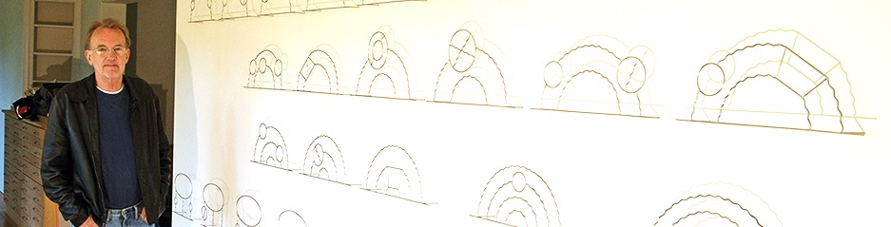

*"In general, I think audiences are a lot smarter than people think. So, it's not ‘know your audience’, it's ‘respect your audience, and really know your content.’"*

*— Edward Tufte, seminar 2010*

Edward Tufte