WRIT 4260 / 5260
Stroupe

Inspirations and Ideas for Series Premise
Series Title:
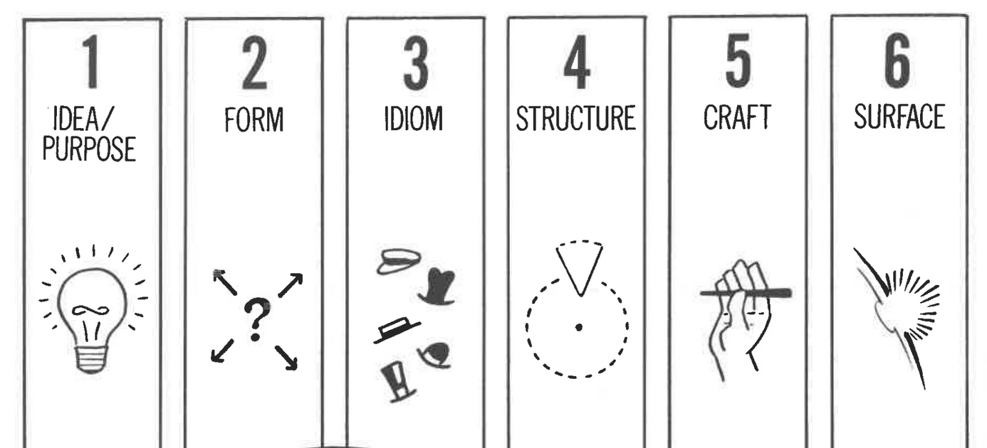

Log Line:

Inspirations and Ideas for Title Sequence

Plot Phrase:

