Stroupe
University of Minnesota Duluth
Active Reading

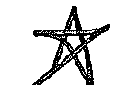 | Occasionally use stars to mark important ideas in the reading as a whole, or ideas that struck you in your reading experience.
 | Mark essential definition of an idea or a useful summarizing statement
 | Use underlining for emphasis and highlighting
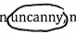 | Circle key terms, phrases, and names (to be looked up later, or just noted and remembered)
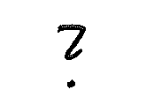 | Note questions, doubts, or confusions that you have as a reader (at the moment of reading): maybe something to think more about later after finishing the reading.
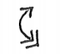 | Use a two-ended arrow to mark where the writer is setting up an important opposition, distinction, or binary: “this vs. that.” If the writer seems to be privileging one side of the opposition over the other, make that end of the arrow double-headed.
 | Arrows coming together mark a key synthetic connection or comparison: “this is connected to or is similar that.” (This is especially useful if the comparison is surprising or unconventional.)
 | Mark parallels that are suggested between ideas or examples (similar to connections and comparisons above)
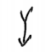 | The writer here is telling or suggesting a story or narrative progression: “this leads to, causes, or follows that.”
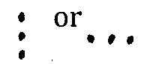 | Keep track of items in a list or parts of a discussion. (For instance, the “five characteristics of this,” or “the six results of that.”) If the writer numbers the items, you might also use numbers instead of dots.
 | Write small, short marginal notes to record your mental associations or thoughts arising at that moment of reading. These may be personal and fleeting.
 | Mark particularly vivid examples or specific cases of an idea or point.
 | After finishing the reading, look back and decide on a few pages that were prominent in your experience of the text. Draw a small diagonal line in the upper, outside corner of these pages to mark them as essential and so you can easily find them later.  (You might cheat and mark some pages as you’re reading, but avoid marking too many pages as essential or the distinction loses its meaning.)

