Craig Stroupe

**Visual Styles**

|  |  |
| --- | --- |
| A | B  ttp://www.ibiblio.org/wm/paint/auth/gris/gris.picasso.jpg |
| C  http://images2.fanpop.com/images/photos/2800000/Mr-Burns-in-Real-Life-the-simpsons-2883512-949-1002.jpg | D  http://www.bschool.com/wp-content/uploads/MrBurns.gif |

E



F

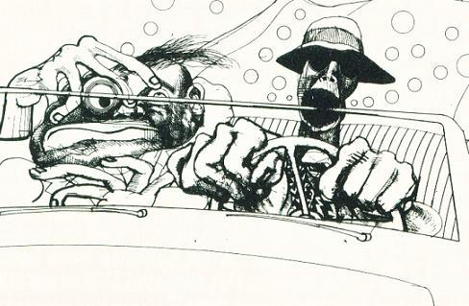

G

