Stroupe
WRIT 4260 / 5260
Compartment and Callouts Workflow

Specific steps and directions for following the workflow below can be found at Affinity Photo’s Help site at https://affinity.help/photo/en-US.lproj/index.html

Terms in bold can be entered in the search field for detailed instructions and explanations.
Terms after “Menu:…” explain how to navigate the left-hand menu of the Help site to find directions for that tool or process.
Feel free to do online searches for more explanations as you need them.

- With your image file open, choose the Shape Tool and draw a shape (a square or circle) in your image.
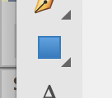
- With the Move Tool, move and resize the shape as desired.
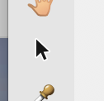
- The options panel of the Move Tool will enable you to fill and/or stroke the shape (fill means to add an opaque or semi-transparent background color; stroke means to outline the shape with a line).
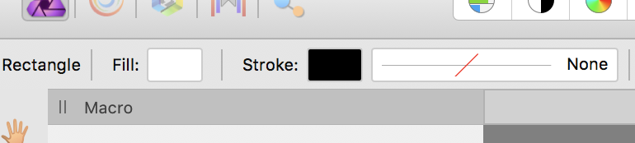
- To create another compartment or callout, simply choose “Duplicate Layer” in the Layers Panel and then, in the document, use the Move Tool to move and resize the duplicated layer as desired.
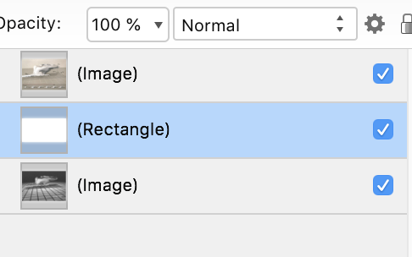
- Note that you can group layers to keep your Layers Panel better organized. This technique allows you nest together layers you select into nameable folders that you can close and open to reduce clutter.
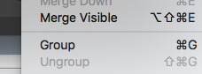
- Save your image.

