Stroupe
WRIT 4250

Audacity Workflow for the Writing in Layers Project

GETTING HELP
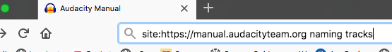

1. To find directions for using particular tools and techniques in Audacity,
- go to the front page of the online software’s manual:
https://manual.audacityteam.org
- in front of the ULR, type “site:” (see image above)
- after the URL, type a space and your search term(s)

——————————————————————————————————————————
MANAGING ALL YOUR SOURCE FILES
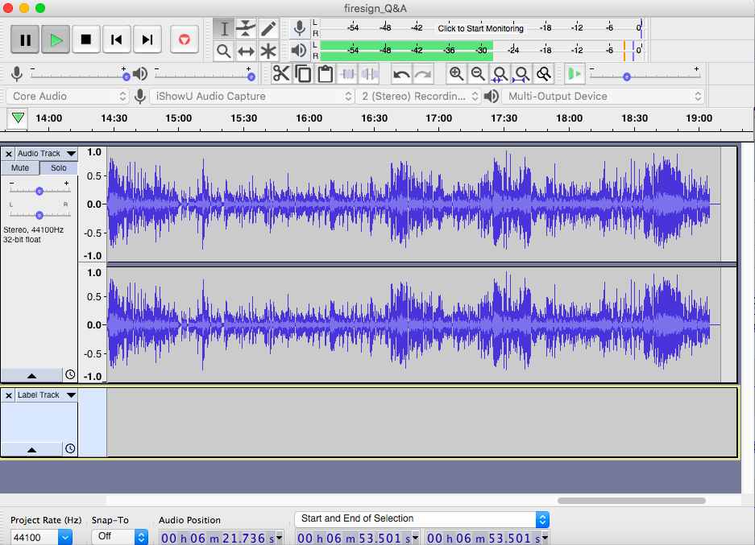
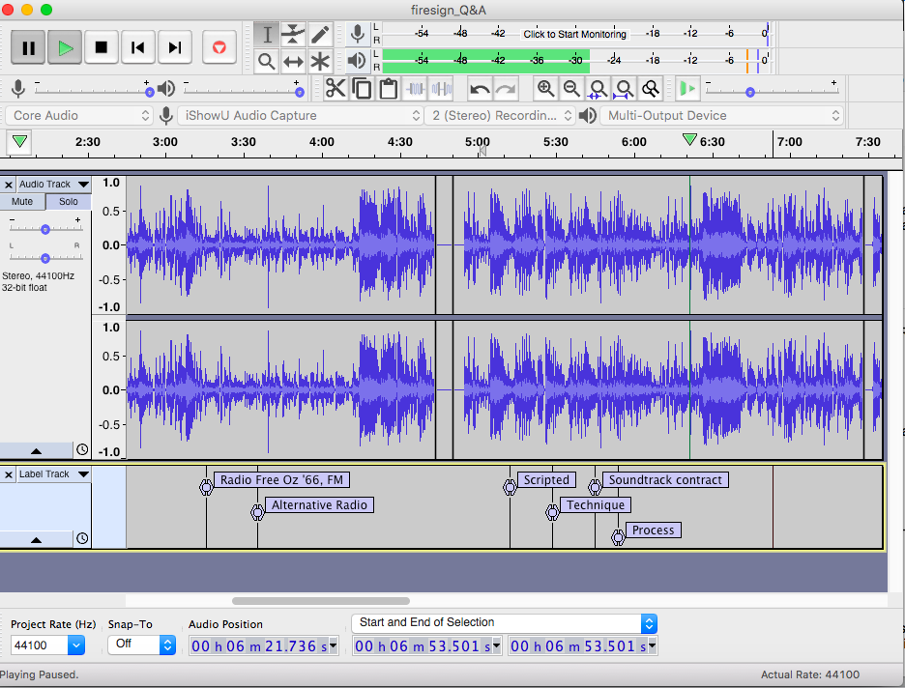
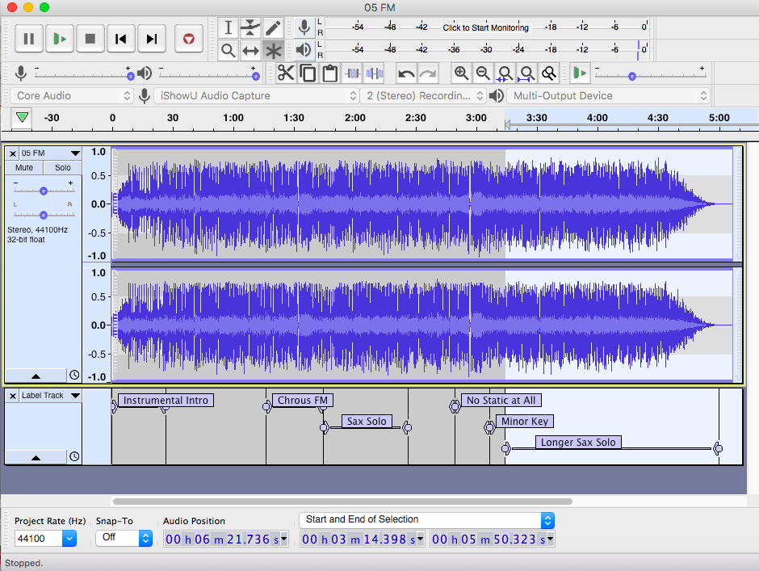

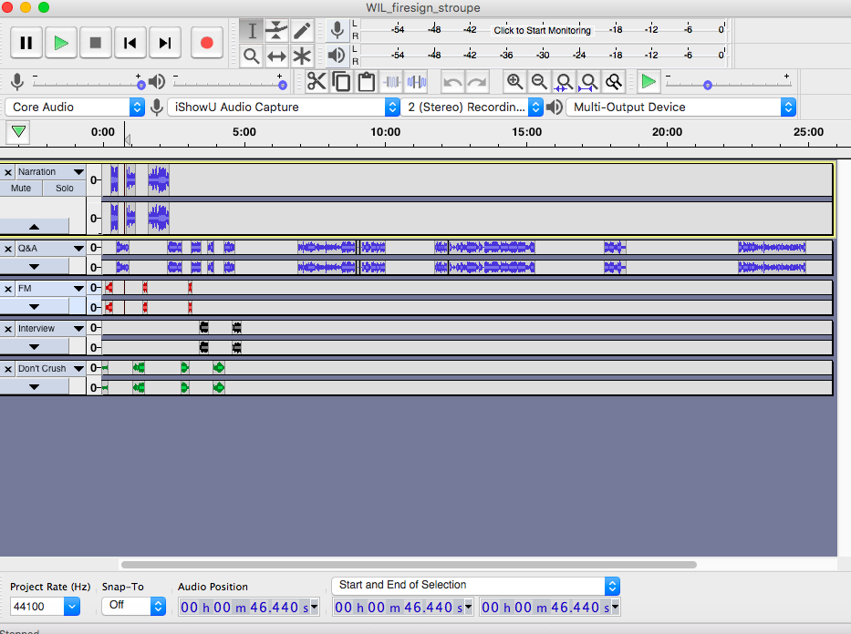

2. Open or import each of your sources into its own Audacity file (known as a “project”), and save it with a unique file name. (Hint: File > Open or File > Import)

Have a separate Audacity file for your project itself, into which you can copy and paste portions (know as “clips”) from your sources into their own tracks.

——————————————————————————————————————————
LABELING KEY PARTS OF YOUR SOURCE FILES

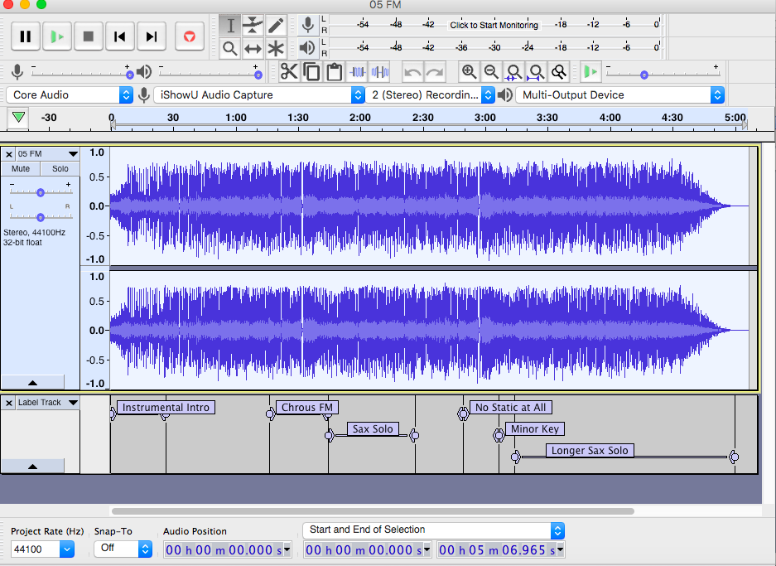

Use labels in Audacity to help you locate and remember key points and segments in your sources. Doing this will help you find the portions that you want to copy and paste into the project’s main file.

Hint: Edit > Labels > Add Label at Playback Position or Selection, or use the quick command [in Mac] Command+b

——————————————————————————————————————————
SEARCH TERMS FOR DIRECTIONS AND DETAILS
Appearing in bold below are search terms for key tools, tutorials, techniques to look up in Audacity’s online manual.

BASICS (search for multiple words in these titles)
“Tutorial - Editing an Existing Audio File”
“Tutorial - Mixing a Narration With Background Music”

CLIPS
Split tracks into separate clips using Cut and Paste
(use the same technique to move, sample, or delete portions of tracks)
Move clips forward or backward on the a track’s timeline with the Time Shift Tool

TRACKS
Silence tracks in a mix with Mute
Precisely control and vary the relative volume of a track with the Envelope Tool
Change the volume of a track across the entire timeline with the Gain Slider
Vary the color of different tracks by choosing one of four waveform colorways

FILES
Save your files (projects) as .aup files (Audacity files) on your computer.
Note that Audacity will create an accompanying resource folder, which needs to be kept next to the .aup file in order for your project to continue to function.
Export your project as a web-compatible audio file (.wav or .mp3)
Enable Audacity to export in .mp3 format by installing the LAME Encoder

