WRIT 4260/5260
Stroupe
Excel Charts

1. Open a “worksheet” in Excel, enter numbers and labels into the page as desired.

A. File > Open

2. Select the cells with the numbers and labels to include in the chart.

A. Drag cursor diagonally to highlight desired cells.

3. Choose style of graph and create it.

A. Click the “Charts” tab from the menu near the top of the Excel workspace.
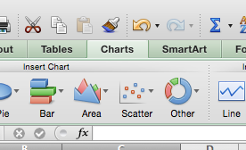

B. From the horizontal menu of charts, choose one and click the tiny arrowhead to open up the submenu of choices.
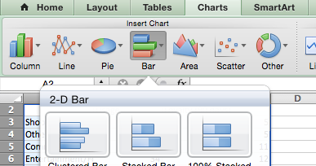

C. With the cursor, click on a choice to create chart.

4. Change the chart style.

A. Click on the chart to select it
B. From the menu of chart types and choices, click a different style of chart. Notice that the chart changes

5. Change the size of the chart or move it around in the worksheet.

A. With the cursor, grab the lower right corner and drag outward to make the chart larger.
B. Move the chart around in the window by dragging it by one of the straight edges.

6. Revise the ordering of the data in the worksheet and chart

A. Click away from the chart to deselect it.
B. If necessary, re-select the numbers and labels in the worksheet by dragging diagonally.

C. From the menu at the top, choose the “Data” tab.
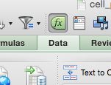

D. From the Data menu times that appear, open the “Sort and Filter” submenu and choose “Custom Sort…”
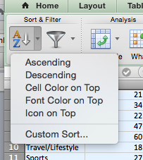

(continued next page…)

E. From the “Sort” window, choose the column you want to use the re-sort all the data, and the kind of order you want (for example, Smallest to Largest, Alphabetical, etc.). Click OK. Both the worksheet and the chart should change.
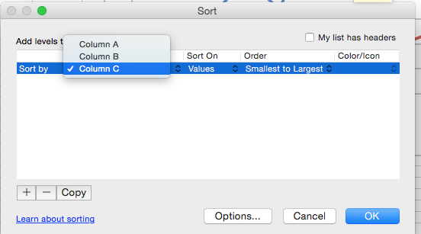

7. If desired, change the background color of the chart to transparent (a useful option for eventually working with the chart in Photoshop)

A. Right-click (or Control+click) on the background near the edge of the chart, and choose from the fly-out menu, “Format Chart Area…”
B. From the left menu in the “Format Chart Area” menu, choose Fill
C. From the “Color” menu, choose “No Fill”
D. Click OK
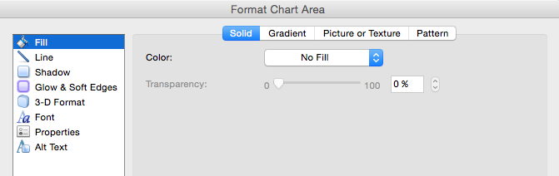

E. Right-click (or Control+click) on the background in the middle of the chart, and choose from the fly-out menu, “Format Plot Area…”
F. Repeat steps 7C and 7D to change the background for the plot area.

8. Save the chart as an image file that can be opened in Photoshop or uploaded to the web.
A. Right-click (or Control+click) on the “chart area” (outer edge) of the chart.
B. From the fly-out menu, choose “Save Picture As…”
C. Save the image (in the default .png format to preserve transparency) where you can open it in Photoshop if desired.
D. Be sure to save the Excel worksheet: File > Save.

