WRIT 4260/5260
Stroupe
iMovie: Title Sequence Basics
(iMovie version 10.1.2)

First, here are the names of the primary areas of the iMovie 10.1.2 workspace, called “panes”:
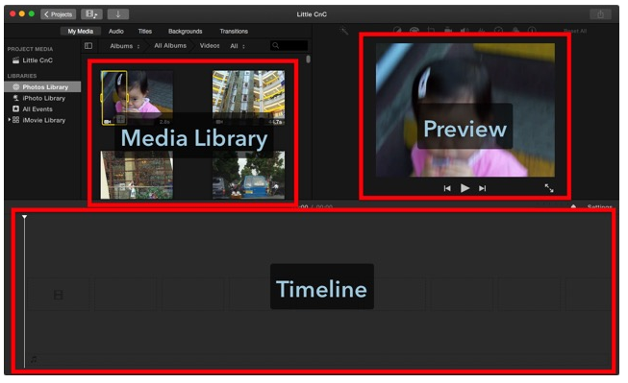

1. Create a new movie in iMovie and re-name it.
A. From iMovie’s main menu at the top, choose File > New Movie
B. (If given the choice—it depends on the version of iMovie you’re using⎯choose “No Theme” and give your project a name.)
C. If not given a choice, give the project a meaningful name by clicking the “Projects” button in the upper left of the workspace:
D. In the Projects screen, find the icon for the generically named “My Movie,” and click open the menu:
E. Double-click the project icon to open it again.

2. Import your media files (images and audio).
A. Choose File > Import Media
B. Navigate to the images and audio files that you downloaded (following directions from the course web site).
C. Select files to import, and click the “Import” button.
D. You should see the newly imported files appear in the Media Library Pane.

3. Move image files for your movie into the Timeline.
A. From the Media Library Pane, select and drag the image icons down into the Timeline. (You can cherry-pick files to select by Command-Clicking them one after another and then dragging them as a group.)

Note: Once they’re in the Timeline, we’ll refer to image or audio files as “clips.”

4. Sequence the clips. After previewing your movie, re-sequence them as desired.
A. In the Timeline, drag the image icons (clips) around to sequence them in the order you want.
B. Click on the first clip, and then, up in the Preview Pane, click the Play button.
C. In the Timeline, drag any image icon into a different location in the sequence if desired.

5. Change the duration of each clip and preview.
A. In the Timeline, click on a clip to select it (yellow outline).
B. From the menu at the top of the Preview Pane, choose the Clip Information Tool.
C. In the “Duration” box, enter a different number of seconds to shorten or lengthen the duration of the clip.
D. Do the same for the other clips and preview the movie.

Notice that the clips expand the length according to the run time they occupy on the Timeline.

6. Add audio to the movie and preview.
A. From the Media Library Pane, drag the audio icon down into the Timeline. The green audio icon will nest under the row of image icons, expanding across the Timeline to show the audio’s run time.
B. As desired, drag the audio icon to the left or right to control when the audio begins in relation to the image clips.
C. In the Timeline, click the first image icon, and then click Play in the Preview Pane.
D. As desired, change the duration of the image clips to coordinate them with the audio.

7. Add panning and zooming effects within each shot using the Ken Burns Effect to introduce camera work into your project.
A. In the Timeline, click on a clip.
B. From the menu at the top of the Preview Pane, choose the Cropping Tool:
C. You will now see two frames superimposed on the Preview: a Start Frame and an End Frame. iMovie will use these two frames to create the appearance of a camera panning or zooming through the duration of the clip. The Start frame is selected first by default:
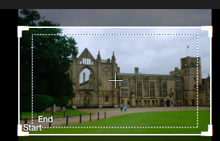

D. Drag the handles in the corners of the Start Frame to resize the view at the beginning of this clip. You can also click in the middle of a frame and drag it around on the image to center it on any portion of the image.
E. Click on the “End” Frame to select it. Resize and reposition the Ending view using the same processes.

8. Add transitions between shots and preview
A. From the menu at the top of the Media Library Pane, choose “Transitions.”
B. Choose a transition from the icons shown, and then drag the transition icon down to a space between two clips in the Timeline. (You can also insert transitions at the beginning of the first shot and at the end of the last shot).

9. Edit durations of transitions.
A. In the Timeline, double-click on a transition icon that you previously inserted to select it:
B. In the pop-up window that appears, enter the number of seconds for the transition to take.
C. Click the “Apply” button.

10. Add two images of your own choosing to the sequence, edit durations, transitions, etc.
A. Choose images from your USB or, with a web browser, download and save them from the web.
B. In iMovie’s main menu at the top, choose File > Import Media
C. Navigate to the images and audio files that you downloaded (following directions from the course web site).
D. Select files to import, and click “Import All.”
E. From the Media Library, drag the new image icons down into the desired locations in the Timeline. Edit the durations, transitions, etc. for the new clips.

11. Add titles to your clips.
A. Click on a clip in the Timeline
B. From the menu across the top of the Media Library Pane, choose “Titles.”
C. Choose and drag an option for a title from the Media Library Pane, onto a clip’s icon in the Timeline.
D. In the Timeline, select the blue label above the clip’s icon .
E. In the Preview Pane, select the title’s default text and type in your own text.
F. With the text selected, reformat the title as desired using the contextual menu at the top of the Preview Pane:
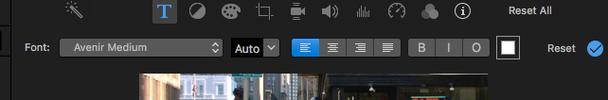

12. Consider filters to give your images a particular, unifying look and feel.
A. Click on a clip in the Timeline
B. From the icons above the Preview Pane, choose the Clip Filter icon:
C. Click open the Clip Filter menu and select any desired filters from the “Choose Clip Filter” pop-up window, or click the “Cancel” button to choose no filters.

13. Share the movie as a .mp4 file
A. From the main menu at the top, choose File > Share > File…
B. In the “File” window, leave the various options in their default settings and click “Next.”
C. In the save window that appears, name the file in the “Save As” box. Be sure to leave the extension “.mp4” as is.
D. Navigate to the location on your USB drive where you need to save the finished product.
E. Click the “Save” button.

14. Test the .mp4 file in a browser
A. In a web browser, choose File > Open File (commands may vary browser by browser)
B. Navigate to where you saved the .mp4 file and select it.
C. Click the “Open” button.

15. IMPORTANT IF YOU ARE NOT WORKING ON YOUR OWN MAC.
Follow the directions in the handout, “Saving an Unfinished iMovie Project for Completion Later,” semester pages:

Saving a library of projects on your USB drive enables you to keep and continue to work on them even when you’re moving from Mac to Mac, or when you come back to the lab after the public computers have been re-imaged (that is, wiped clean).

