EE 2212 QUIZ 1 S. G. Burns
24 September 2021
Name:_______________________
All quizzes are open book, open notes, open WEB (but watch your time management). Be sure your name is on all sheets of paper. Submit pdf, WORD, jpg, scan, etc. t0 sburns@d.umn.edu

Problem 1 (40 Points) Thevanin Equivalent Circuit and Ideal Sources
- (20 Points) Derive the Thevanin equivalent circuit for the DC circuit shown below. All inductors and capacitors are ideal. Clearly specify V_{TH} and R_{TH}.
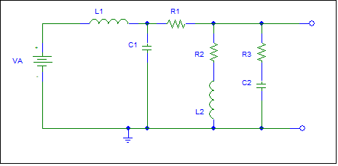
- (20 Points) Sources-Circle Answer
- The Thevanin resistance of an ideal independent voltage source is (zero, infinite, determined from the circuit).
- The Thevanin resistance of a dependent voltage source is (zero, infinite, determined from the circuit).
- The Thevanin resistance of an ideal independent current source is (zero, infinite, determined from the circuit).
- The Thevanin resistance of a dependent current source is (zero, infinite, determined from the circuit).

Problem 2 (30 Points, 5 Points Each) Phasors
- The voltage gain of a system is given as A_{v} = 500∠90°. Compute A_{v}(dB)._______________________
- The voltage gain of a system is given as A_{v} = 0.002∠30°. Compute A_{v}(dB). ______________________
- The power gain of a system is given as A_{p} = 1000 Compute A_{p}(dB). ____________________________
- ( Points) Suppose I have two peak phasor voltages, V₁ = 100∠45° and V₂ = 75∠-60°. Circle Your Choices:
- The frequencies associated with the phasors are (0 Hz, 60 Hz, 50 Hz, Unknown).
- The rms values of the first phasor is (100, 70.7, 141, 200) volts.
- If you want to add these two phasors, the frequencies must be (60 Hz, 50 Hz, The same, Integer multiples of a given frequency.)

Problem 1 (30 Points) Power System Standards and Related
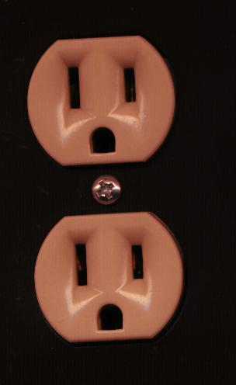
Assume a standard duplex outlet is wired correctly and meets the National Electric Code (U.S.) The load is operating correctly with no defects in operation or internal wiring. Answer the following:

- (18 Points) Write a time domain, rms phasor, and peak phasor
expressions for the voltage between:
- Short slot with respect to the long slot

(ii) Short slot with respect to the round hole

(iii) Long slot with respect to the round hole

(b ) (6 Points) The National Electric Code specifies that a circuit breaker or fuse must always be located in the
(NEUTRAL WIRE, HOT WIRE, GROUND WIRE) of a power distribution system and this wire is color coded
(GREEN OR BARE, BLACK OR RED, WHITE) and would connect to the
(ROUND HOLE, SHORT SLOT, LONG SLOT) of a standard duplex receptacle.

- (6 Points) The current in the ground conductor ideally is
(10% of the current in the black wire, 10% of the current in the white wire, Zero, 90% of the current in the black wire, 90% if the current in the white wire).

