EE 2212 QUIZ 2 S. G. Burns
4 October 2021
Name:_______________________

Problem 1 (30 Points, 3 Points Each) I Am Sure You Expected This! Fill in the following Table. The data sheet posted on the EE 2212 Course WEB page could be very very useful.

SPECIFICATION | IDEAL OP AMP | μA 741
Input Resistance (Typical)
Output Resistance (Typical)
Voltage Gain (Typical)
Bandwidth (Typical)
Maximum power supply voltages | XXXXXXXXXXXXXX
Maximum short circuit current | XXXXXXXXXXXXXX
Problem 2 (30 Points) Cascaded Op Amp System
Assume ideal operational amplifiers therefore you can use summing point constraints. Write time-domain
equations for v3(t), v4(t), and v5(t) in terms of the circuit elements. Observe, no calculations are required.
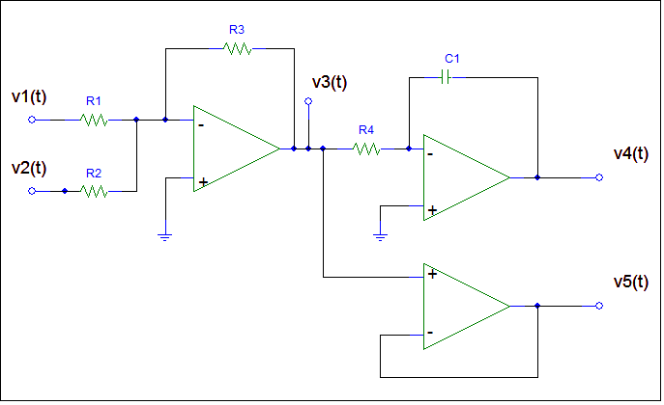
v1(t) = _______________________

v2(t) = _______________________

v3(t) = _______________________

v4(t) = _______________________

v5(t) = _______________________

Problem 3 (40 Points) Design a three channel audio equalizer/mixer circuit using a μA741 operational amplifier. Apply the following input signals. The electric guitar amplifier design in Problem Set 2 should be helpful.

Input Signals and Voltage Gain Design Criteria:
v₁(t) must have a voltage gain of 26 dB

v₂(t) must have a voltage gain of 12 dB

v₃(t) must have a voltage gain of 20 dB

Your design must include:
- (25 Points) Detailed and well-labeled circuit diagram. Including a set of self-consistent values for all four resistors with design justification. Resistor values must be compatible with a μA741 (Refer to your answer in Problem 1, last line)
- (10 Points) An equation for the resultant output voltage, v_{o}(t). Phase is important!
- (5 Points) The three input frequencies are 500, 5000, and 50,000 radians/second. Are these three signals within the normal human hearing range of someone in the 20 something age range? Explain.

