EE 2212 QUIZ 3 S. G. Burns
13 October 2021
Name:_______________________
Design a +40 volt dc power supply for your sound system. Your sound system requires a 400 watt capability. The power supply is energized from a three-wire 110 V_{rms} 60 Hz power line that meets the National Electric Code (NEC). The system block diagram and design specifications are given below.
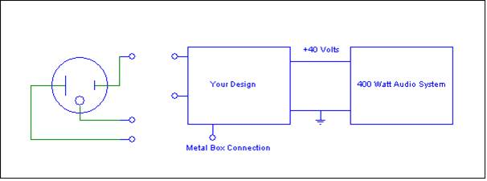

DESIGN SPECIFICATIONS
- Input is a 110 V_{rms} 60 Hz
- Output voltage is 40 volts
- Maximum allowable ripple is 2%
- Use a full-wave bridge rectifier
- Use a transformer
- Assume diodes with V_{F} = 0.7 volts

YOUR DESIGN MUST INCLUDE:
Well-labeled circuit diagram of what goes in the “Your Design” box. There should be enough detail such that someone could build an operational prototype. Polarities of key components as are the diode orientations are important
Key design equations and supporting calculations. Show your work!
Component specifications including:
- Transformer-turns ratio
- Effective value of the audio system load resistor (speaker impedance) and load current for a 400 watt, 40 volt system.
- Capacitor value to satisfy the 2% ripple voltage specification.
- Bridge rectifier, correctly oriented, with diode-current and power ratings.
- Correctly located primary circuit fuse and its rating.
- Correct (NEC specified safe wiring) to the three wire power line receptacle. Be sure you show the fuse location.

