EE 5621 QUIZ 4 27 October 2021
PROBLEM 1 (37 Points, Parts (a), (b), (c) 9 Points each, Part (d) 10 Points) Metallization S. G. Burns
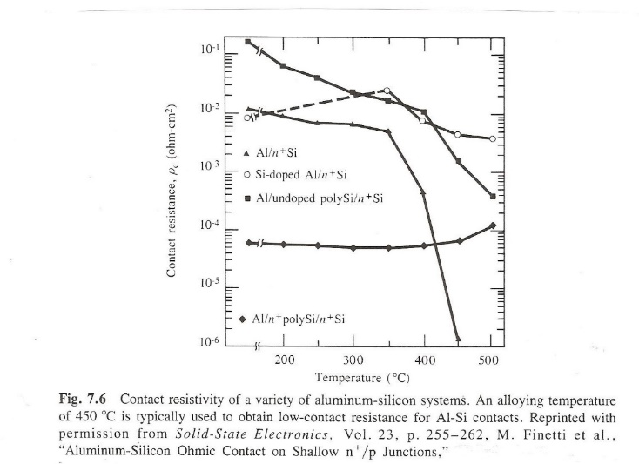
- Sketch the energy band structure and the resultant I-V curve for an n⁺-p⁺ and qualitatively explain why this could be considered an “ohmic” contact.

Problem 2 (63 Points) Deposition Pot-Pourri
- 1 Atmosphere, like you would hear on a weather forecast corresponds to about ______bar, _____torr , ______inches of Hg.
Select from one of the following to answer the Parts (b) through ( ) EVAPORATION, SPUTTERING, CVD, MBE.
(b)____________Good step coverage is a problem.
(c) ____________Good for III-V heterostructures.
(d) ____________Usually used for growing thick layers of Polycrystalline Si.
(e) ____________Very flexible; can deposit semiconductors, metals, and dielectrics
(f) ____________ W (tungsten) deposition on the interior of an incandescent light bulb
(g) ____________Requires a high DC potential for depositing metals on the substrate (anode)
(h)____________Requires a RF generator, could be a magnetron, to deposit dielectrics such as SiO₂ or Al₂O₃
(i)_____________Best for depositing monolayers of III-V materials

- At 200C, compute the best case for the sheet resistance of a 1 μm thick line.

- Repeat it T= 450C after annealing.

- Compute the contact resistance for Parts (a) and (b) for a 1.5 μm x 1.5 μm via through SiO₂.

