EE 5621 QUIZ 5 S. G. Burns
10 November 2021
Name:_______________________

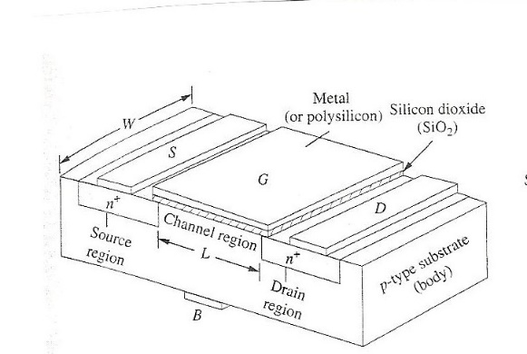
FET Pot-Pourri (12 Points each +4 Points for your name on any sheets you are sending me)

- If the substrate doping is N_{A} = 2 x 10¹⁷ cm⁻³ the inverted channel charge carriers are (HOLES, ELECTRONS, BOTH HOLES AND ELECTRONS, NEUTRONS, PHOTONS) and if the substrate doping is changed to be N_{D} = 2 x 10¹⁷ cm⁻³, the inverted channel charge carriers are (HOLES, ELECTRONS, BOTH HOLES AND ELECTRONS, NEUTRONS, PHOTONS)

- Current technology for “L” is (FEW Å, 5-10 nm, 1 μm, 5-10 μm) and for t_{ox} (FEW Å, 5-10 nm, 1 μm, 5-10 μm)

- The guard ring doping density is (HIGHER, ABOUT THE SAME, LOWER) than the surrounding doped Si resulting in a (HIGHER, ABOUT THE SAME, LOWER) V_{T}.

- LOCOS is used to obtain a field SiO₂ which is (Thinner, About the Same, Thicker) compared to the gate oxide resulting in a (HIGHER, ABOUT THE SAME, LOWER) V_{T}.

- The active region in a TFT is typically fabricated using (X-Si, Poly-Si, a-Si, a-Si:H) and the resultant material μ (mobility) is (HIGHER, ABOUT THE SAME, LOWER) compared to what is expected from a non-TFT MOSFET.

- A student, enrolled in a course similar to our EE 5621 in a large university located in the Twin Cities, suggests that the guard band doping should be 2 x 10²³ cm⁻³ of As in an NMOS. Provide two reasons why this student will probably get a very low grade in their semiconductor course.

- An iPhone 13 has a 2532 x 1170 RGB OLED display. The display would be described as (Emissive, AMLCD, LCD) with an aspect ratio of ___________ and the display is fabricated using _________________________ individual OLEDs.

- Assume an NMOS has a threshold voltage V_{T} = 2 volts. Fill in the following table for the regions of operation.
V_{GS} | V_{DS} | Region of Operation
1.0 | 5
3..0 | 5
8.0 | 5

