Stroupe

Setting Up a “www” Site in Dreamweaver and Using It to Upload Files and Folders

This one-time process introduces Dreamweaver to the “www” folder on your USB Drive and to your web space on the server.

Since we are working in a public lab, these settings will not be permanently saved on the computer you’re using. Instead, the last two steps will explain how to save the settings to your USB Drive, and to quickly import them later.

1. Find or create the “www” folder on your USB drive
A. Using your computer’s Finder, make sure you’ve created a folder called “www” in the correct location. (See previous instructions about setting up folders).
The Finder icon on a Mac appears in the tray across the bottom of the screen and looks like this:

B. If you haven’t created a folder called “www,” do so now.

2. In Dreamweaver, open a “Site Setup” window

A. From the menu across the top, choose Sites > Manage Sites

B. In the “Manage Site” window, click the “New Site” button, which will open a “Site Setup…” window.

3. Title the new site “www” and choose the “root folder,” which is your “www” folder.

A. In the “Site Setup…” window, be sure “Site” is selected on the left side

B. In the “Site Name” box, type “www”

C. To the right of the “Local Site Folder” box, click the folder icon

D. Using the “Choose Root Folder” window that opens, navigate to the “www” folder you created.

E. Select the “www” folder so it’s showing in the box at the top of the “Choose Root Folder” window like this:

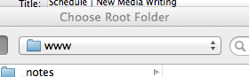

F. Click “Choose” at the bottom of the “Choose Root Folder” window.

Continued Next Page >

4. Enter the “remote site” information for your “www” site

A. In the “Site Setup…”Window, look on the left and choose “Servers” from the menu.

B. From the bottom of the blank box on the right, click the “+” symbol:

C. At the top of the window that appears, be sure the “Basic” button is selected.

D. Enter the information below in the window.

Type your UMD userid and password instead of mine.

Be sure to change the “Connect using” default from “FTP” to “SFTP” using the drop-down menu. This setting is required by UMD’s security protocols.
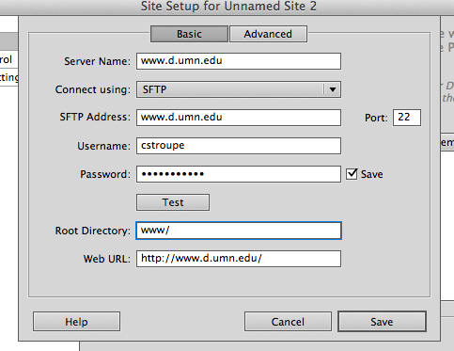

Do NOT click save yet….

5. Test the connection and then remove your password for security

A. In this same window, click the “Test” button until you receive a alert that Dreamweaver has connected successfully.

If you receive an alert saying there was an error, check the information you entered in this window again, especially your userid and password

B. Once you’re sure these settings allow you to connect successfully to the server, uncheck the “Save” check box next to the Password box.

This means that, if you were to forget to log off the computer in the lab, no one will be able to open Dreamweaver and gain access to your web space on the server. By not saving your password here, Dreamweaver will prompt you to enter it every time you upload files to the server.

C. At the bottom of the “Site Setup…” window, click the “Save” button.

D. In the “Manage Sites,” click “Done.”

6. Find the “www” site files in Dreamweaver’s “Files” Panel

A. After Dreamweaver completes the process of creating your new site, look on the right side of the Dreamweaver workspace to find the “Files” Panel, which will look something like the screen shot below.

If you don’t see the Files Panel on the right, choose from the top menu Window > Files

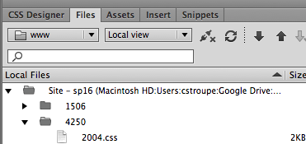

You can create a different site for each project—each of which will have its own root folder inside of your “www” folder (and inside of the subfolder you were asked to create for this class: for example, “4250” or “4230”).

This “www” site is set to look at the entire “www” folder, which will contain all the files and folders that your upload to the server.

This “www” site is therefore the primary means will use to do these uploads, using the processes below.

7. Upload your www subfolder for this class to your web space on the server.
A. At the top of Dreamweaver’s Files Panel, be sure the “www” site is chosen from the menu:
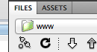

B. In the “Local Files” window of the Files Panel, select your web folder for this class (for example, “4250”) to upload to the server.

C. At the top of the Files Panel, click the “Put” button, which looks like an Up Arrow:
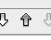

D. If you get an alert asking if you really want to “put” the entire site, click “OK.”

8. Compare the contents of the site files on your USB to the site files now on the server.
A. At the top right of Dreamweaver’s Files Panel, click the Expand/Collapse button, which looks like this:
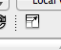

B. Dreamweaver will temporarily expand the Files Panel to a window which will show your “www” site files on your USB drive (the “Local Files” in the right window), and in your web space on the server (the “Remote Server” in the left window).

C. In the Files window, compare the files and folders in your www subfolder for this class in the right pane to the version in the left pane to be sure they match. The idea is to make these mirror images of one another.

If you want to make changes to your files or folder, the safest means is to make changes to them on your USB drive (the version in the “Local Files”) and then upload the “www” folder (or just the subfolder which contains the changes).

D. To return the “Files” panel to its usual side and location, click the “Expand/Collapse” button at the top of the Files window.

9. How to upload a single folder or file from the “www” folder
When you make changes to a particular file or folder, you can upload just that one item rather than uploading the entirety of the “www” folder contents again.

A. In the Files Panel, select the folder or individual file you need to upload (being sure you’ve saved the file first!)

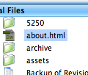

B. At the top of the Files Panel, click the “Put” button (Up Arrow) to upload the selected file or folder.

Note that you can “Command-click” multiple files and folders to cherry-pick those you want to select, even if they’re not adjacent.

9. Make the contents of your www subfolder for this class (e.g., “4250”) accessible by saving a blank web page, labeled “index.html,” into that folder.

This step is necessary to satisfy university security protocols. You will need to copy this “index.html” page into any folder in which you have files that you want to be accessible by a web browser.

A. From Dreamweaver’s menu across the top, choose File > New
B. From the left menu of the New Document window, click “Blank Page.”
C. Under “Page Type,” choose “HTML”
D. Under “Layout,” choose “none.”
E. At the bottom right, click “Create.”
F. With the new, blank page appearing in the document window, choose from the top menu, File > Save As
D. In the “Save As” window, navigate to the folder where you want to save the page: in this case, the web folder for this class. Be sure the name of that folder appears in the drop-down menu bar at the top, like this:

E. In the “Save As” box at the top, type the file name, “index.html”
F. In the bottom right of the “Save As” window, click “Save”
G. In the Files Panel on the right, open the www subfolder for this class by clicking the tiny triangle next to it. When it opens, you should see the “index.html” file as well as any folders you created in the subfolder previously.

10. Save your “www” site information on your USB drive so you won’t have to set it up again.

A. Choose from Dreamweaver’s menu across the top, Site > Manage Sites

B. Select the site from the “Your Sites” pane.

C. At the bottom of the “Your Sites” pane, click the Export button, which looks like this:
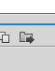

D. When you see the alert titled “Exporting site ‘www’” asking if you intend to “Back up my settings…,” click “OK”

E. In the “Export Site” window that appears, navigate to the top level of your USB Drive and then click the “Save” button on the bottom right.

Dreamweaver will save the site settings as a file called “www.ste” in the location you’ve chosen. The file name “.ste” means “site.”

11. How to recover your site settings when you return to the lab.

In a public lab, your site settings in the copy of Dreamweaver running on the desktop are erased when you log out. When you open Dreamweaver, you can recover the site settings with the following steps.

A. From the top menu of Dreamweaver, choose Site > Manage Sites
B. In the “Manage Sites” window, click the “Import” button
C. In the “Import Site” window, navigate to the location where you previously saved your site information (a file titled “www.ste”).
D. With “www.ste” select, click the “Open” button.
E. In the “Manage Site” window, click “Done.”

Dreamweaver will import the “www” site information, and your folders and files contained in your your “www” folder should appear in the File Panel. Since the “remote site” information has also be imported, you will also be able to upload file and folders using the “Put” command.

