WRIT 4230/5230
Stroupe
Setting Up Sites, Uploading Files, Exporting Site Information

1. "Introduce" Your Site to Dreamweaver
1. Follow the steps in McFarland for setting up Dreamweaver to move files between your USB and the Web server. You will also need the following UMD-specific information.
2. In setting up your "remote info" (a.k.a. "Server" information), you will need the information particular to UMD's server below. You'll use your UMD login and password in place of mine.
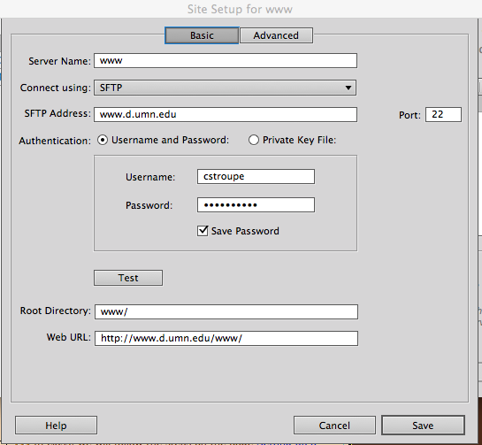
3. From the “Connect Using” menu, be sure to choose "SFTP". Because of security, file transfer won't work without this option.
4. After clicking the "Test" Button, deselect the "Save" check box so you don't risk leaving your password-protected files vulnerable on the public computers in the lab.

2. Post your "4230" Folder to the Web
1. In the “Files” panel on the right side, click once on the "4230" folder to highlight it.
2. At the top of the Files Panel, find the Up-Arrow Icon (also known as the "Put" command). Click that Up Arrow to "put" the 4230 folder up on the server.
3. You may be prompted to provide your password (if you followed the direction above)

3. Visit your "4230" folder on the web
1. Go to UMD's home page.
2. In the browser's location bar at the top, click at the end of the URL "http://www.d.umn.edu/" and type in a tilde (~), your userid, a forward slash, and "4230" so it looks like this: http://www.d.umn.edu/~youruserid/4230.
3. Now continue typing the names of nested folder leading down to the particular folder you want to reach. For example:
http://www.d.umn.edu/~youruserid/4230/exercises/Chapter01
(Note that you don’t need to enter the folder “www.” Your userid automatically puts you in the “www” folder on the server. )
4. If the page you want to see is called anything besides “index.html,” you’ll need to add the page’s file name after the folder name with a “/” in between. Example: http://www.d.umn.edu/~youruserid/4230/exercises/Chapter01/about.html
5. Hit Return (or Enter)
6. You should see the page in your browser window. If you don’t,
A. Check to see that you’ve entered in a valid path to through the nested folders
B. Be sure that the folder you’re trying to access contains an “index.html” page. UMD’s security requires such a page in each folder to make it accessible.

4. Submit the URL of your Page for Credit to the Appropriate Moodle Forum
1. With your page appearing in the browser window, copy the URL from the browser's location bar at the top
2. Visit the Moodle forum specified in the today’s directions
3. Choose to reply to my the at the top
4. Paste in the URL
5. Make the URL clickable by highlighting the pasted URL, and clicking the link icon above the message window
6. Paste the URL again into the "URL" box and click OK

5. Export Your Site Information (First Time Only)
When you move from computer to computer--or come back to a lab computer later--you will find that the sites you set up in Dreamweaver have disappeared. It's very helpful, then, to be able quickly to reinstate your site settings without having to recreate the site from scratch:
- Choose "Site > Manage Sites > Export."
- Save the exported site information (in a .ste file) at the top level of your USB drive where it will be easy to find.
- [When you come back later--or move to a different computer--choose "Site > Manage Sites > Import" to navigate to your USB drive and choose "www.ste" to import. You can make .ste files for as many of your sites as you wish.]

