UNIVERSITY OF MINNESOTA

Duluth Campus Department of Anthropology, 228 Cina Hall
Sociology & Criminology 1123 University Drive
College of Liberal Arts Duluth, Minnesota 55812-3306

Office: 218-726-7551
http://www.d.umn.edu/socanth
Email: socath@d.umn.edu

15 April 2018

Anthropology Senior Seminar Week 14

Groups II Presentation

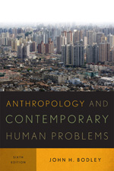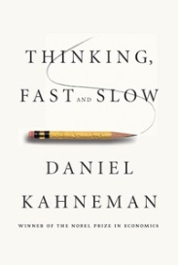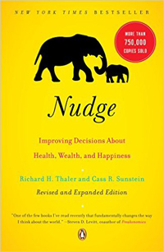

This week will be a great week as the fruits of your labors continue to be revealed.
Monday’s feature Group Research Presentation . . .

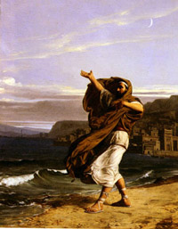

Wednesday (and Monday, the 23rd of April 2017) we review some of the selected items remaining on the docket for the remainder of the semester . . .

On the Docket

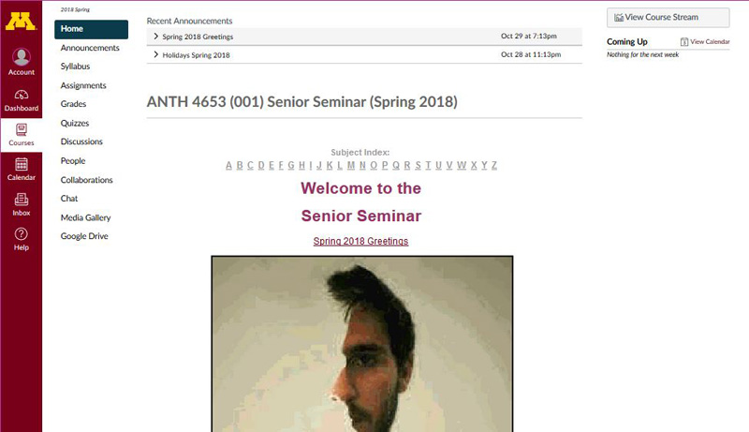

    - Cognition: Perception / Conception
      - REM Optical Illusions . . .
  - Chabris, Christopher F., and Daniel J. Simons.
    - The Invisible Gorilla: How Our Intuitions Deceive Us. NY: Crown Publishing Group / Random House, 2011.
      - REM Roshomon Effect . . .
- Daniel Kahneman
  - Thinking, Fast and Slow (2013)

    - Heuristics
    - Fallacies
    - Biases
- Richard H. Thaler
  - Richard H. Thaler and Cass R. Sunstein, Nudge: Improving Decisions About Health, Wealth, and Happiness, Revised and Expanded Edition. NY: Penguin (2009)
- Nassim Nicholas Taleb
  - Incerto -- an investigation of luck, uncertainty, probability, opacity, human error, risk, disorder, and decision-making in a world we don’t understand

    - Fooled by Randomness: The Hidden Role of Chance in Life and in the Markets (2005)

    - The Black Swan: Second Edition: The Impact of the Highly Improbable: With a new section: "On Robustness and Fragility" (2007/2010)

    - Antifragile: Things That Gain from Disorder (2014)

    - The Bed of Procrustes: Philosophical and Practical Aphorisms (2016)
    - Skin in the Game: Hidden Asymmetries in Daily Life (2018)

- Malcolm Gladwell

      - The Tipping Point: How Little Things Can Make a Big Difference (2002)

      - Blink: The Power of Thinking Without Thinking (2007)

      - What the Dog Saw: And Other Adventures (2010)

      - Outliers: The Story of Success (2011)

      - David and Goliath: Underdogs, Misfits, and the Art of Battling Giants (2015)

- Statistics

- Basics
  - Descriptive
  - Inferential
  - Standard Deviation
  - Rates
  - Demography
    - Population Pyramids
    - Italy slides: (.pptx)
  - Cf., Nassim Nicholas Taleb above
- Ethics
- Skills Highlights

- Major Characteristics
slides: (.pptx)
  - Holism
    - Systems Analysis

  - Units of Analysis
      - slides: (.pptx)
  - Comparative Analysis
  - Quantitative-Qualitative Description and Analysis
    - “Bottom-up” Approach
  - “People Skills”
    - Linguistic and Communication Skills
  - Global Perspectives
    - Emic and Etic

  - Long-range Perspectives

    - Diachronic Viewpoints

  - Great Perennial Debates
slides: (.pptx)

  - History of Ethnological Theory
  - Alternate Facts / Truth

- Video (time permitting):
      - "Global Challenges and Anthropology"
Part 16 of the series Cultural Anthropology: Our Diverse World,
(30 min., 2008,UM Duluth Library Multimedia GN357 .C8 2008 DVD, Pt. 16)
- Final Exam
- Evaluations / Feedback
- In the News, some examples . . .
- tba

The Information Technology Systems & Services (ITSS) will be sending you an
Invitation to Participate in an Online Course Evaluation.

Evaluations are important to me, the Department Head, and the Dean, as well as everyone in our Department.

Please fill the online Course Evaluation out carefully.

Evaluations are anonymous, and will not be seen by the instructor until final grades for this course have been recorded.

Thanks.

Assignments and Events
. . . this week are listed on your (1) ”Calendar”, and the (2) “Syllabus” sections of your folder.

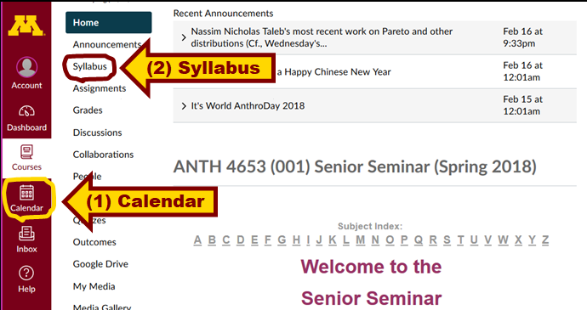

(1) This Week’s ”Calendar”

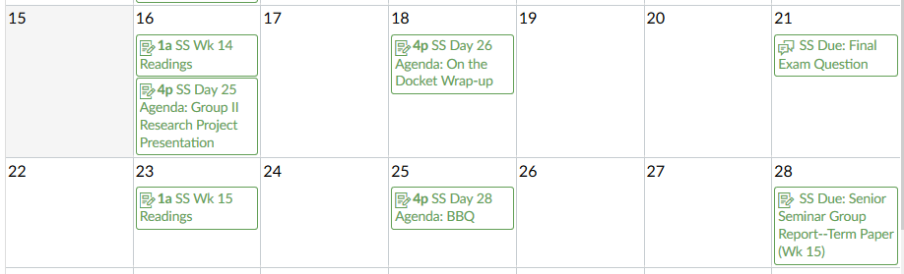

(2) This Week’s “Syllabus”

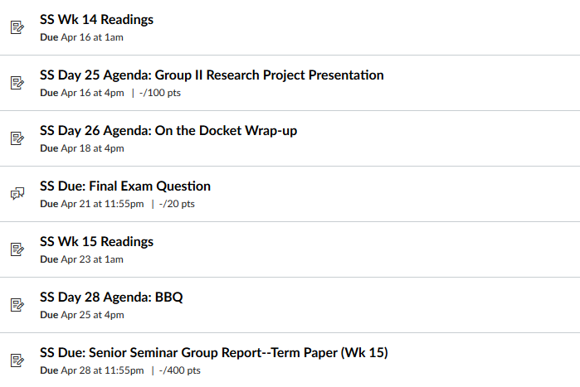

REM: Your Term Paper is due this week

REM contribute your final exam question . . .

SS Due: Final Exam Submitted Question
Due Apr 21 at 11:59pm -/20 pts

If you have any questions right now, about just about anything—please do not hesitate to post them on the Course “Chat”, or e-mail troufs@d.umn.edu , or stop in before or after class across the hall in Cina 215.

Best Regards,

Tim Roufs
<http://www.d.umn.edu/~troufs/

