Roufs, Timothy G. 2018. "Hot Dish." From We Eat What?: A Cultural Encyclopedia of Unusual Foods in the United States, by Jonathan Deutsch, (Ed.). Santa Barbara, CA: ABC-CLIO, pp. 171-176.

Hot Dish
On a freezing day in the Upper Midwest a type of casserole known as “hot dish” brings great joy to hearty folks, especially to those needing to prepare a tasty, nutritious, convenient, simple, thrifty, mix-it-together meal while on a busy schedule, and especially on those occasions calling for “potluck” or picnic comfort food contributions. Whether it be the famed “Tater Tot Hot Dish” so loved by the Norwegian bachelor farmers of Garrison Keillor’s [mythical] Lake Wobegon, Minnesota, or the delicious deluxe North Dakota “Funeral Hot Dish” served in the church hall of a Swedish Lutheran congregation, hot dish warms the bodies and hearts of Midwesterners gathered for whatever occasion in Minnesota, western Wisconsin, northern Iowa, and eastern North and South Dakota. In short, says StarTribune columnist Sharyn Jackson, in the Midwest, “hot dish is not just dinner; it’s a way of life” (2015). She notes that hot dish welcomes, comforts, and provides sustenance, survival, and social glue wherever Midwesterners gather. And, since most hot dishes can be prepared in advance and refrigerated or frozen until needed, they are instantly and conveniently available at the drop of a visitor’s hat.
The classic post-World War II Tater Tot Hot Dish combines a can of Campbell’s cream of something soup (from 1934 onwards, usually cream of mushroom soup, aka “Lutheran binder”), with “some hamburger” (i.e., ground beef), “some” frozen tater tots, “some” frozen vegetables, maybe “some” cheddar cheese, and milk, and an onion, mixed together in a two-quart casserole dish, which is then baked in a “moderate oven” for an hour “or until taters are brown and crusty.” (“Tater Tots®” is a registered trademark of the Ore-Ida division of Kraft Heinz that is used generically in the vernacular of hot dish country.) Ingredients, amounts, proportions, and cooking times vary from dish-to-dish, from day-to-day, from cook-to-cook, and from congregation-to-congregation, as do the punchlines of the many Tater Tot Hot Dish jokes. Minnesotans and Wisconsinites often upscale their basic Tater Tot Hot Dish offerings with the addition of their states’ famous mahnomen (i.e., wild rice), resulting in a tasty high-end Wild Rice Hot Dish delight highlighting the region’s native grain.
Prior to the arrival of Campbell’s condensed cream soups in 1934, and Tater Tots® in 1953, hot dish aficionados relied heavily on noodles, macaroni, and sometimes rice. The first recorded hot dish recipe is most often said to be that appearing in the 1930 Grace Lutheran Ladies Aid Cookbook from Mankato, Minnesota, a recipe calling for two pounds of hamburger, Creamette® brand elbow macaroni, and canned peas (Heffelfinger, 2015).

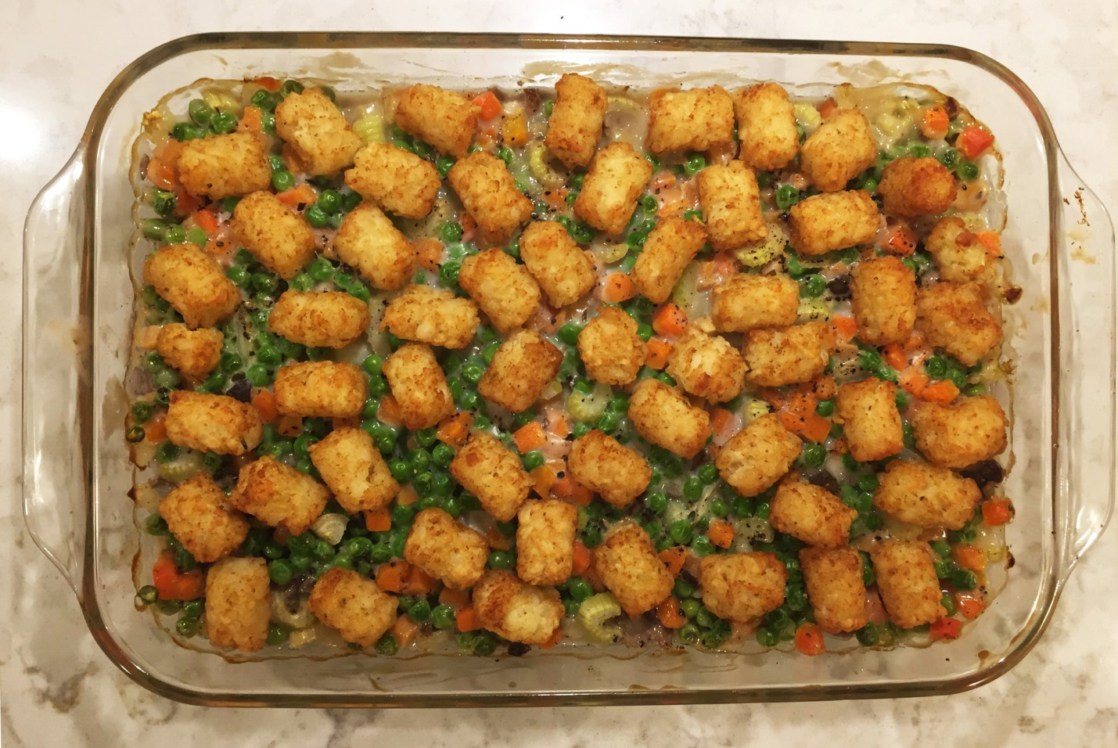

The Campbell Girls’ Tater Tot Hot Dish

Photo by Gretchen Roufs Woodfield
Little research has been done on hot dish. While hot dish is commonly associated with Scandinavian Lutherans, its initial popularity may actually have been fostered by events surrounding the Great Depression of the 1930s and World War II (1939 to 1945). The documentary Minnesota Hotdish: A Love Story suggests the now iconic fare first became a staple during the Great Depression when it was popularized as an inexpensive yet nourishing way to feed a family when food and fuel were scarce. Government and food industry home economists and nutritionists distributed recipes for casseroles, and newspapers printed suggestions for low-cost meals, while cooking en casserole became a favorite topic of food columnists, further entrenching hot dish as the Midwestern go-to all-in-one nutritious meal. Tom Isern, Professor of History & University Distinguished Professor at North Dakota State University, specifically questions the idea that the hot dish “is a particularly Lutheran (or Norwegian or Swedish or German) institution” (2003). Professor Isem investigated this notion in the collections of the Institute for Regional Studies at North Dakota State University and discovered that “well into the twentieth century, hot dishes were almost unknown in Lutheran circles” (Isern, 2003). Professor Isern continues on to note that, “Where hot dishes first showed up was in the cookbooks of Anglo-American women in such institutions as the Federated Women’s Clubs. The convenient casserole resulted from the drive for efficiency and timesaving in the kitchens of women with English surnames. Lutherans and other descendants of more recent immigrants adopted hot dish ways later” (2003). Lamenting that hot dish proliferation has today “gone too far,” Professor Isem proposes a “Lutheran Recipe Factory Formula” for hot dish creation: “Simply choose your ingredients from three groups, taking care to include at least one from each group.”
“Group 1: Bulk. This includes hamburger meat, tater tots, canned tomatoes, canned pork & beans, frozen mixed vegetables, elbow macaroni, fruit cocktail and Rice Krispies®.”
“Group 2: Lubricants. Select from cream of mushroom soup, cream of celery soup, cream of chicken soup, Cheez Whiz®, ketchup, evaporated milk, butter and more butter.”
“Group 3: Fancy Stuff. Here add chocolate chips, marshmallows, Jell-O®, M&Ms®, pimento-stuffed olives and canned French-fried onions.”
“Have I left anything out? Whatever, throw that in, too.” (Isern, 2003)
Experienced Midwestern cooks have followed at least the spirit of Professor Isern’s approach for generations. Catholics, although usually having an entire section of meatless hot dish recipes in their church cookbooks, most often turn to tuna hot dish with crushed potato chips on top for their for meatless Friday and Lenten meals. And as author Theresa Millang notes, “As the years marched on, Minnesota, a heavily Scandinavian populated state, began to incorporate other foods in new hot dishes. Tex-Mex became very popular. Then came Cajun, Creole, tofu, Southern, and more Chinese hot dishes. The possibilities are endless” (1999, 2-3). Minnesota SPAM® Hot Dish, however, remains an “acquired taste” for many.
For generations, family-favorite hot dishes have been satisfying hearty Midwesterners. Everyone, of course, thinks their hot dish is exceptional, although folks in small communities do allow modest recognition of hot dish virtuosos. All agree, however, that the best hot dish is that which their mother made. My mother’s family’s hot dish is legendary, and one still fervently served by great-great grandchildren:

The Campbell Girls’ Tater Tot Hot Dish

SERVES 4 to 6

1 lb. ground beef
1 onion, chopped
1 can mixed vegetables (or 16 ounce bag of frozen mixed vegetables)
16 ounces frozen tater tots
1 can cream of mushroom soup
1 can milk

Method: Brown beef and onion. Place in 9 x 13 inch baking dish. Mix up the milk and soup, then stir in the vegetables. Add remaining ingredients and top with frozen tater tots. Bake 350 degrees for one hour or until taters are brown and crusty.

Adapted from Feasts From Friends. St. Martha’s Society Cook Book Committee, Holy Trinity Church. Winsted, Minnesota, 1971, 219. Recipe originally submitted by Mrs. Milo “Keene” Kubasch.

While no state, Midwestern or otherwise, is brazen enough to claim hot dish as their state food—hot dish eaters most often tending to be on the modest and shy side—individuals in the food and beverage industry have proposed the fourth Sunday in September (by which time the weather has cooled to prime hot dish eating temperatures) as official Hot Dish Day in Minnesota—no doubt a prelude to its eventual canonization as the Official State Food.
It is inevitable that hot dish enmeshes Midwestern politics. One finds hot dish ever-present on campaign trails. Sporting the motto, “Working together to improve the lives of Minnesotans, one hot dish at a time,” the Minnesota Delegation of the United States Congress each year hosts an annual hot dish competition, under the leadership of Sen. Al Franken (D-Minn). The 2016 winner of the 6th annual Hot Dish Off, an entry by Rep. Tim Walz (D-Minn)—“Tim’s Turkey Taco Tot Hotdish”—was a bi-partisan culinary success. Sen. Franken's second-place "Land of 10,000 Calories Hotdish," and Sen. Amy Klobuchar's (D-Minn.) third-place "Babe the Brew Ox Steak and Ale Hotdish," bested Rep. Betty McCollum's (D-Minn.) "Making Hotdish Great Again Hotdish," which, although it fared only as runner-up in the contest, will no doubt become a favorite of the Trump administration (KARE, 2016).
Senator Al Franken, who grew up on hot dish, started the Minnesota-nice U.S. Congress competition to at least briefly put partisanship aside, and bring the delegation together in celebration of a great Minnesota culinary tradition. As a grade-school lad in St. Louis Park, Minnesota, young Alan Franken fueled his early acting and stage career with his mother’s hot dish creations. Phoebe’s Peach Noodle Kugel, a specialty of his mother, was a favorite:
Phoebe’s Peach Noodle Kugel

MAKES 12 TO 15 SERVINGS

8 ounces uncooked medium egg noodles (about 3 cups dry noodles)
4 eggs, well beaten
½ cup granulated sugar
½ teaspoon salt
2 cups creamed cottage cheese
2 cups sour cream
¼ cup butter, melted
about 4 cups drained, canned peach slices (two 15-ounce cans)
Cinnamon
Granulated sugar

Heat oven to 350 F.

Cook noodles as directed on package. Drain noodles; place in buttered 13-by-9-inch pan. Fold together beaten eggs, sugar, salt, cottage cheese, sour cream and melted butter. Pour egg mixture over noodles. Arrange drained peach slices, placing them closely in rows, atop ingredients in pan. Sprinkle lightly with cinnamon and sugar.

Bake uncovered 45 to 50 minutes or until knife inserted in center comes out clean.

From Hot Dish Heaven: Classic Casseroles from Midwest Kitchens. Ann L. Burckhardt. St. Paul, MN: Minnesota Historical Society Press, 2006, 162-163.

Hot dish inspires Midwestern politics, as well as church and civic cookbooks, songs (Keillor, 1988), literature (Cooney, 2013; Dennis, 2000), poetry (Dennis, et al, 2005), film (Bartholdi, 2013), ceramic arts (Minnesota Clay Center, 1995), fabric and fiber arts (Atkinson, 2000), comedy (Bartholdi, 2013; Mohr, 2013), souvenirs and hot dish kitsch (MHS, 2017), and even a “Minnesota Nice Hot Dish Red” wine “which pairs really well with tater tot hot dish” (Chaffins, 2014). Midwesterners feed on hot dish, whether it be SPAM® Tater Tot Hot Dish, Potluck Hot Dish, Breakfast Hot Dish, Funeral Hot Dish, Congressional Competition Hot Dish, Unexpected Company Hot Dish, Baby Shower Hot Dish, Brunch Hot Dish, or Minnesota Nice Neighbor-is-Sick Hot Dish (Millang, 1999, 2). Our favorite State Fair food? Ole and Lena's Tater Tot Hot Dish on a Stick, of course.
In short, in the Midwest hot dish is not just dinner; as they say, “It’s a way of life”!

Further Reading

Atkinson, Terry. Minnesota Hot Dish.” Atkinson Designs. Elk River, MN Atkinson Designs, 2000.

Burckhardt, Ann L. Hot Dish Heaven: Classic Casseroles from Midwest Kitchens. St. Paul, MN: Minnesota Historical Society Press, 2006.

Chaffins, Amy. “Hot dish: Should it be our state food?” Echo Press. Last updated 26 September 2014. Accessed 20 January 2017. http://www.echopress.com/content/hot-dish-should-it-be-our-state-food.

Cooney, Jeanne. Hot Dish Heaven: A Murder Mystery With Recipes. St. Cloud, MN: North Star Press, 2013.

Dennis, Pat, et al. Hotdish Haiku. Minneapolis, MN: Penury Press, 2005.

Dennis, Pat. Hotdish to Die For: A Collection of Culinary Mystery Short Stories [in which hot dish is the weapon of choice]. Minneapolis, MN: Penury Press, 2000.

Heffelfinger, Julia. “The History of Hot Dish.” Food & Wine. Last updated 30 December 2015. Accessed 21 January 2016. http://www.foodandwine.com/blogs/history-hot-dish.

Isern, Tom. “Plains Folk: Hot Dishes.” News, North Dakota State University—NDSU Agriculture Communication. Last updated 14 February 2003. Accessed 20 January 2016. http://www.ext.nodak.edu/extnews/newsrelease/2003/021303/04plains.htm.

Jackson, Sharyn. “Let's dish on hot dish, Minnesota's homegrown casserole: Minnesota's homegrown casserole is made with more than Tater Tots.” StarTribune. Last updated 22 April 2015. Accessed 21 January 2016. http://www.startribune.com/let-s-dish-on-hot-dish-minnesota-s-homegrown-casserole/300937641/.

KARE Staff. “Walz wins Congressional hot dish contest.” KARE-11, Minneapolis | St. Paul, MN. Last updated 11 May 2016. Accessed 20 January 2017. http://www.kare11.com/news/walz-wins-congressional-hot-dish-contest/185522156.

Keillor, Garrison, and Jean Redpath. "Tuna, the Food of My Soul." Prairie Home Comedy, 1998. Accessed 22 January 2017. https://www.youtube.com/watch?v=LzyI_Hh8ufI.

Millang, Theresa. The Great Minnesota hot dish. Cambridge, MN: Adventure Publications, 1999.

Minnesota Historical Society. Minnesota Hotdish Towel and Hot Pad. Accessed 31 January 2017. http://shop.mnhs.org/products/minnesota-hotdish-towel-and-hot-pad?variant=1209195953.

Minnesota Hotdish: A Love Story. Maria Bartholdi, Producer. Documentary produced for KSMQ public television. Austin, MN: 2013 (28:47). https://vimeo.com/65158243.

Minnesota Northern Clay Center. Minnesota Hot Dish: March 10-April 28, 1995 (Exhibition Catalog). St. Paul, MN, 1995.

Mohr, Howard. How to Talk Minnesotan: Revised for the 21st Century. NY: Penguin Books, 2013.

Nehil, Tom. “Minnesota hotdish: the documentary.” MINNPOST. Last updated 02 May 2013. Accessed 21 January 2016. https://www.minnpost.com/minnclips/2013/05/minnesota-hotdish-documentary.

Schmierbach, Edie. “Mankato cookbook credited with printing first hot dish recipe.” Mankato Free Press. Last updated 21 February 2016. Accessed 22 January 2016. http://www.mankatofreepress.com/news/local_news/mankato-cookbook-credited-with-printing-first-hot-dish-recipe/article_889f7bf6-d436-11e5-bfd0-0fb51ed60de6.html.

Tran, Lina. “Everything You Need to Know About Hotdish: All about the nostalgic Upper Midwest staple.” Eater. Last updated 15 May 2016. Accessed 21 January 2017. http://www.eater.com/2016/5/15/11611558/what-is-hotdish.

I would like to thank Colin Baumgard, Shelby Brossart, Cassey Chastain, Angella Hallgren, Charles Mundale, Austin Paul, Gretchen Roufs, Kathleen Smyth Roufs, and Peter T. Roufs for their reviews and critiques of this entry. Photo courtesy of Gretchen Roufs.

Timothy G. Roufs

