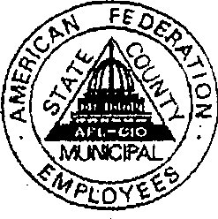AFSCME

Please patronize Duluth's union bars, restaurants & hotels:
HOTELS: Holiday Inn • Radisson
RESTAURANTS: Greenery • Pickwick • Porter's • Sneaker's • Top of the Harbor • BARS: All American Club • Blue Crab Bar • Carmody Irish Pub • Fifth Avenue Lounge • Kom-on-Inn • North Pole Bar - O'Gilby's Bar • Reef Lounge • Rustic Bar • T-Bonz Bar • Twins Bar

