Craig Stroupe
REALISM | AESTHETICISM
presents “large and detailed canvases depicting a specified historical period” (including sometimes the present) (Cobley 85)

focuses on a varied society of national scale consolidated from “disparate [local] elements” (Eagleton qtd. in Cobley 88)

sees “localized, personal problems” in “big political and historical” terms (Cobley 88)

focuses on the material existence shared by a “knowable community” (Cobley 80)

often assumes “that there is one, authoritative meaning” which is frequently achieved through an “omniscient” narrative point of view presenting social facts and “common sense” judgments (Cobley 95, 91)

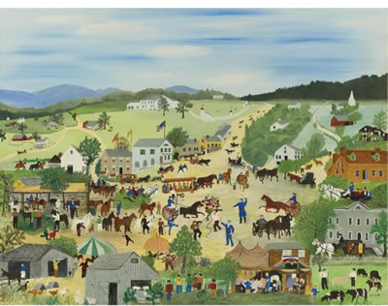 | 

