Craig Stroupe

WRIT 1506

**Modernism**

A style of art and culture characterized by:



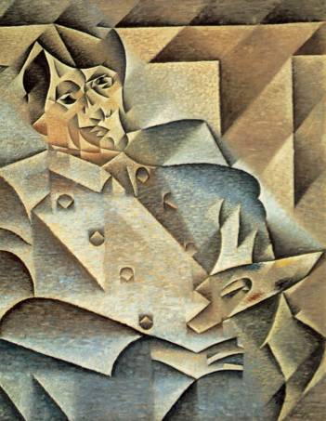

*Piccaso*

by Juan Gris