Craig Stroupe | University of Minnesota Duluth
CSS Layout: New Page, Existing Style Sheet

What to do | How to do it
- Create a new, blank page called “new.html” and save it in the same folder as your css layout exercise. | File > New
- Look at the page that already exists that uses your style sheet, and copy down the IDs of the “divs” | Note that IDs are preceded by “#”  For example: container, header, sidebar1, mainContent  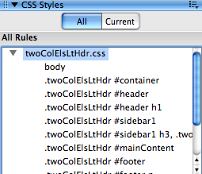
- Create a new “div” on the page with the ID of “container” | At the top of the workspace, choose the “Layout” Tab and choose the first icon “Insert Div Tag”  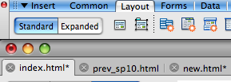  See next page for more in this step…  In the “Insert Div Tag” window, give the new div the ID of “container” and click OK  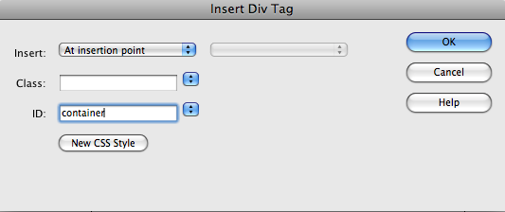
- Inside the “container” div, create one called “header” | In the document, click your cursor at the end of the placeholder text in the “container” div, and hit Return (Enter) to space down.  Same steps as above to create the new div
- Below the div “header” inside of the “container” div, create two more divs with the IDs “sidebar1 and “mainContent” | Same steps as above. Be sure to have the cursor inside of “container” but not inside of the other divs.
- Save the page again | Command (Control) + s
- Attach the style sheet to your new page. | In the Properties Panel, open the “Style” drop-down menu and choose “Attach Style Sheet,” use the “Attach External Style Sheet box to navigate to where your style sheet is saved.  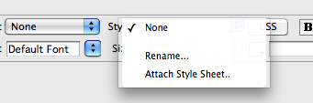
- Be sure the page’s “body” (or any other page elements that are assigned rules via classes) is given the class | On the existing page, look at the tag menu at the bottom of the workspace to see if any classes or IDs are associated with the page’s body. For instance, if there is a class like “.twoColElsLtHdr” following “body” in a tag, it means that rules for how the body of the page looks are being drawn from this “class” (Remember, classes are preceded by “.” .  In the new page, look at the body tag to see if the body is associated with the same class. Notice how nothing follows “body” in the “<body>” tag.  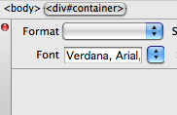  In your new page, right-click on the “<body>” tag, select “Set Class” from the menu that appears, and choose the class “.twoCOlElsLtHdr” from the list (or whatever class is appropriate).
- In the document, remove any unwanted placeholder text and spacing

- Save.

