WRIT 4250/5250
Stroupe
iMovie: Video and Audio Basics
(iMovie version 10.1.2)
First, here are the names of the primary areas of the iMovie 10.1.2 workspace, called “panes”:

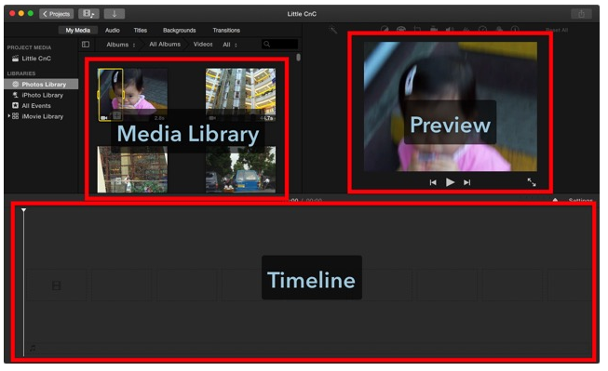

1. Create a new movie in iMovie and re-name it.

A. From iMovie’s main menu at the top, choose File > New Movie
B. (If given the choice—it depends on the version of iMovie you’re using⎯choose “No Theme” and give your project a name.)
C. If not given a choice, give the project a meaningful name by clicking the “Projects” button in the upper left of the workspace:
D. In the Projects screen, find the icon for the generically named “My Movie,” and click open the menu:
E. Double-click the project icon to open it again in the workspace.

2. Import your media files (video, audio, images).
A. Choose File > Import Media
B. Navigate to the images and audio files that you downloaded (following directions from the course web site).
C. Select files to import, and click the “Import” button.
D. You should see the newly imported files appear in the Media Library Pane:
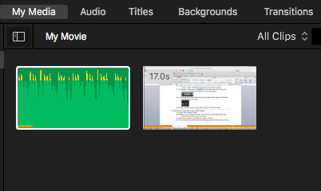

3. Drag video files for your movie into the Timeline.
A. From the Media Library Pane, select and drag a video clip icon down into the Timeline. (You can cherry-pick files to select by Command-Clicking them one after another and then dragging them as a group.)

Note: Once they’re in the Timeline, we’ll refer to video, image, or audio files as “clips.”

4. If desired, remove the audio track from the video clip
A. In the Timeline, select the video clip containing the unwanted audio
B. Right-click on the video clip and, from the pop-up menu, choose “Detach Audio” (or alternatively, choose from the top menu, Choose > Detach Audio).
The video and separated audio tracks will look like this:
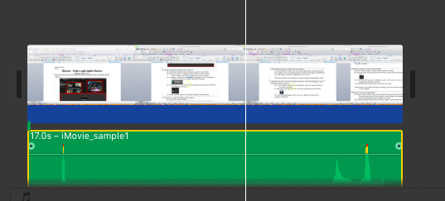

C. In the Timeline, click on the separated audio track and hit “Delete”

5. Add audio to the movie and preview.
A. From the Media Library Pane, drag the audio clip icon down into the Timeline. The green audio icon will nest under the row of image icons, expanding across the Timeline to show the audio’s run time.
B. As desired, drag the audio icon to the left or right to control when the audio begins in relation to the image clips.
C. In the Timeline, click the video clip icon, and then click Play in the Preview Pane. You should see the video clip and hear the audio clip play simultaneously.

6. Delete a portion of a video or audio clip to shorten it or to make it start later.
A. In the Timeline, click on a clip at the point where you want to delete.
B. Holding down the “r” key, drag the cursor to select the portion of the clip you want to delete. You should see the selection outlined in yellow.
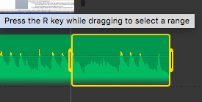
C. Hit the “Delete” key to delete the selected portion of the clip.

7. Adjust the coordination between a video and audio clip.
A. In the Timeline Pane, drag the audio clip to the left or right in relation to the video clip (or vice versa).
B. In the Timeline, click the video clip icon, and then click Play in the Preview Pane.

8. Add panning and zooming effects within a shot using the Ken Burns Effect to introduce camera work into your project.

Note: The pan/zoom effect will begin at the start of the clip and complete at the end of the clip. If you want to zoom out after zooming in, you’ll need to split the track and then apply a zoom-out to the second clip.

A. In the Timeline, click on a video clip in which you want the zoom or pan to take place.
B. From the menu at the top of the Preview Pane, choose the Cropping Tool:
C. You will now see two frames superimposed on the Preview: a Start Frame and an End Frame. iMovie will use these two frames to create the appearance of a camera panning or zooming through the duration of the clip. The Start frame is selected first by default:
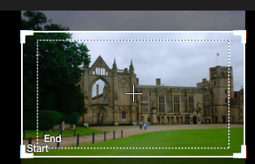

D. Drag the handles in the corners of the Start Frame to resize the view at the beginning of this clip. You can also click in the middle of a frame and drag it around on the image to center it on any portion of the image.
E. In the Preview Pane, click on the “End” Frame to select it. Resize and reposition the Ending view using the same processes.

9. Crop a video clip for a static close up throughout a clip.
Unlike the “Ken Burns Effect,” the “crop to fill” option will apply to the clip for its entire duration.
A. In the Timeline, click on a video clip you want to crop.
B. From the menu at the top of the Preview Pane, choose the Cropping Tool:
C. From the Preview Pane’s top menu, choose “Crop to Fill.”
D. In the Preview, you will see corner handles superimposed on the video image.
E. Drag any of the handles in or out to select the framing you want. You can also drag the selection around by its middle.
F. Hit “Enter” to finalize the crop.

10. Split a video clip into two. Then add a new clip at the split point.
A. In the Timeline, click on a video clip at the point where you want to split it.
B. From the top menu, choose Modify > Split Clip
C. In the Timeline, you will now see two clips
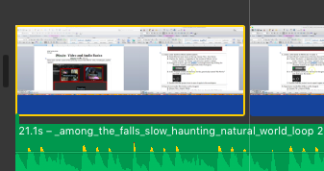
D. In the Timeline, click in the clip before the split
E. In the Preview Pane, click the Play Button to watch the two clips in sequence.
F. You will see that the split is invisible.
G. From the Media Library Pane, drag a new clip into the Timeline. It will appear at a different level from other clips.
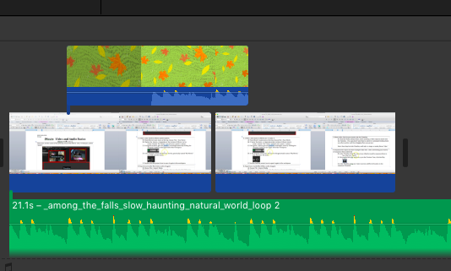
H. In the Timeline, drag and drop the new clip into the split you created above to splice the new clip into the video
I. In the Timeline, click in the video to the left of the new splice.
J. In the Preview Pane, click Play to view your sequencing of clips.

11. Split an audio clip into two, then splice in a new audio clip—using the same process as above.

12. (Very Selectively and Consciously) add clip-to-clip transitions between shots. Editorial Note: Most of the transitions in iMovie are cheesy and distracting.
A. At the top of the Media Library Pane, click the “Transitions” button. You will see the available transitions as thumbnails and names:

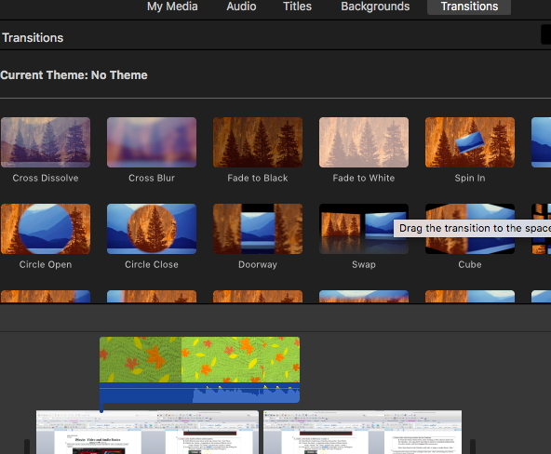

B. Drag the desired transition thumbnail down into the Timeline Pane and drop it into a split between video or image clips.

13. “Share” the movie as a .mp4 file
A. From the main menu at the top, choose File > Share > File…
B. In the “File” window, leave the various options in their default settings and click “Next.”
C. In the save window that appears, name the file in the “Save As” box. Be sure to leave the extension “.mp4” as is.
D. Navigate to the location on your USB drive where you need to save the finished product.
E. Click the “Save” button.

14. Test the .mp4 file in a browser
A. In a web browser, choose File > Open File (commands may vary by browser)
B. Navigate to where you saved the .mp4 file and select it.
C. Click the “Open” button.

15. IMPORTANT IF YOU ARE NOT WORKING ON YOUR OWN MAC.
Follow the directions in the handout, “Saving an Unfinished iMovie Project for Completion Later,” semester pages:

Saving a library of projects on your USB drive enables you to keep and continue to work on them even when you’re moving from Mac to Mac, or when you come back to the lab after the public computers have been re-imaged (wiped clean).

