How to run openchoicedesktop

Run OpenChoiceDesktop software,

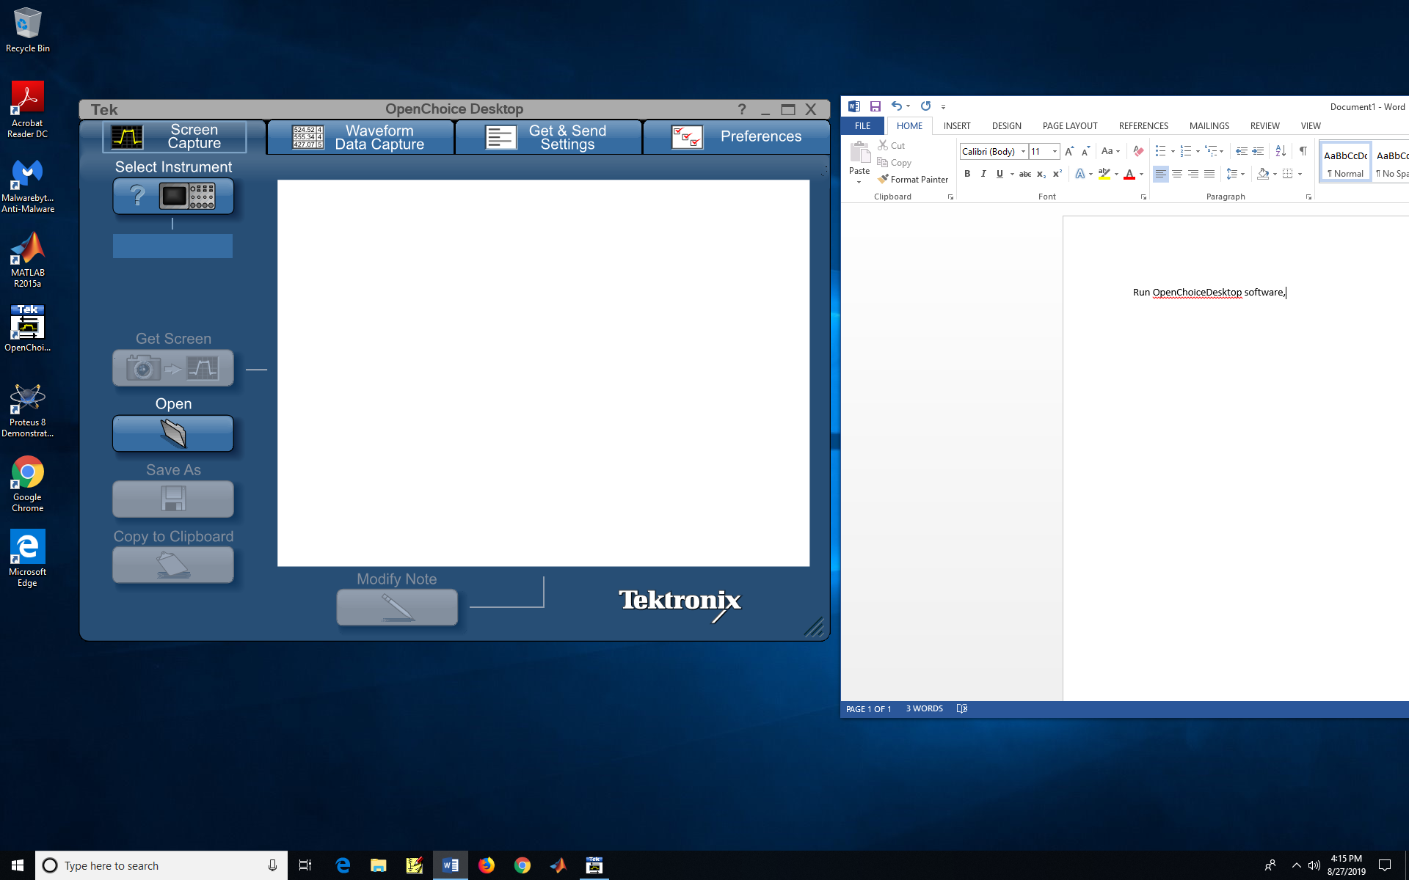

Click select Instrument icon, choose USB:: option

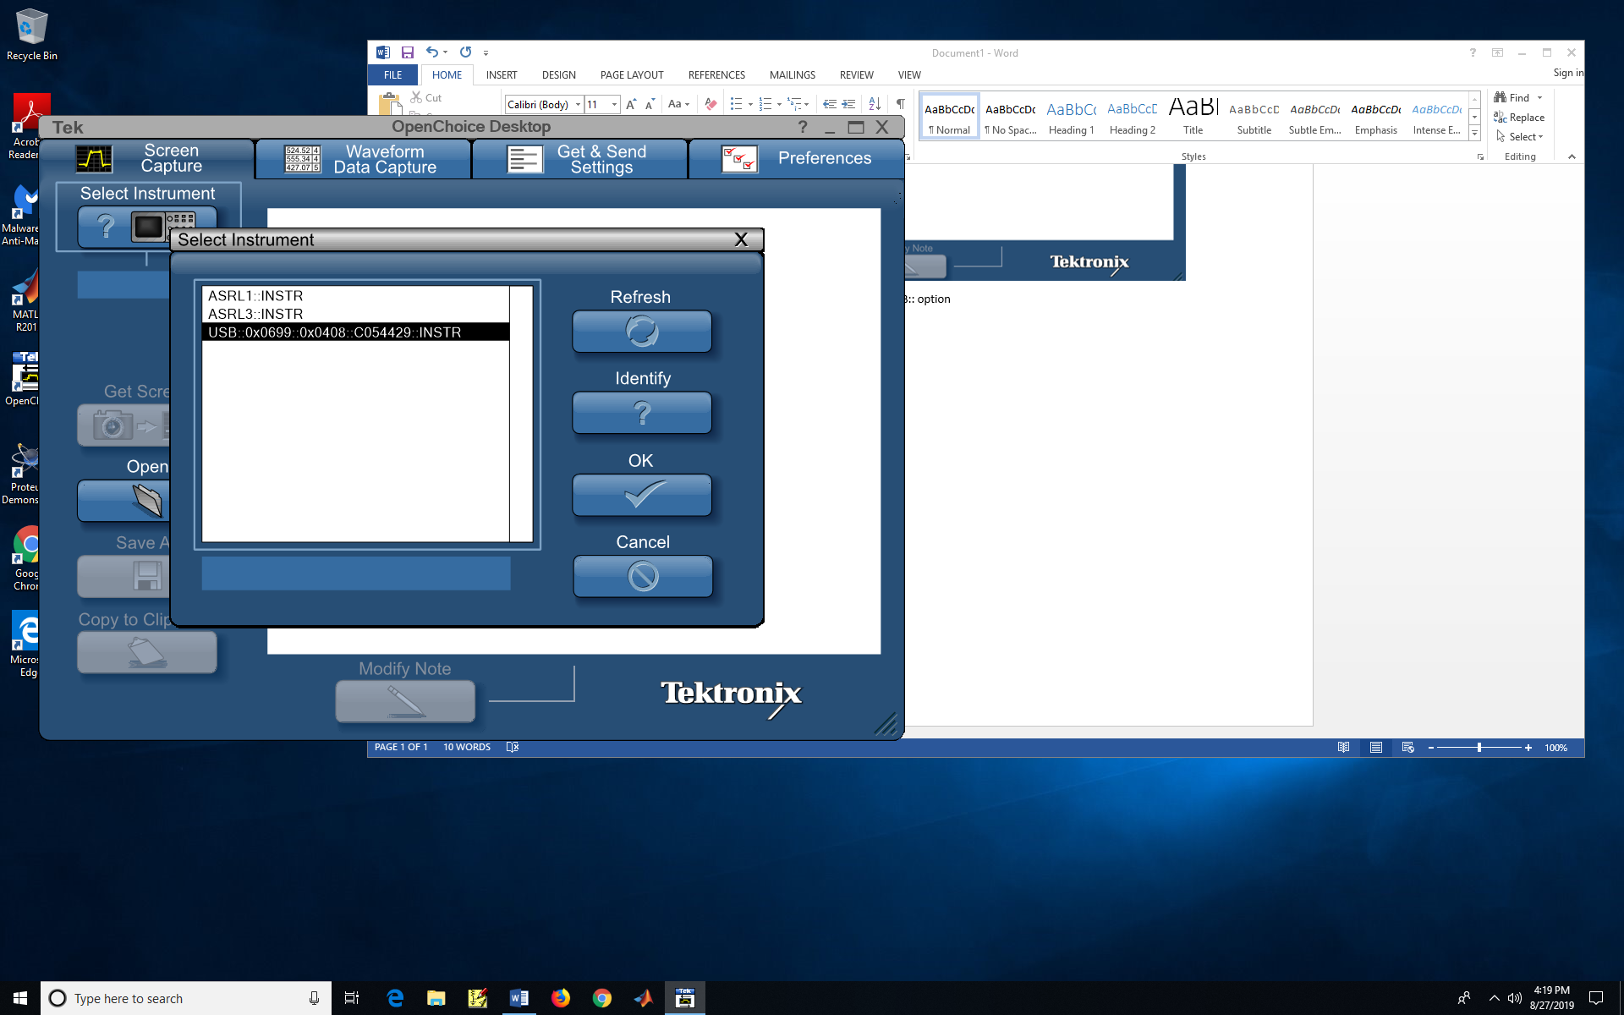

Then click OK.

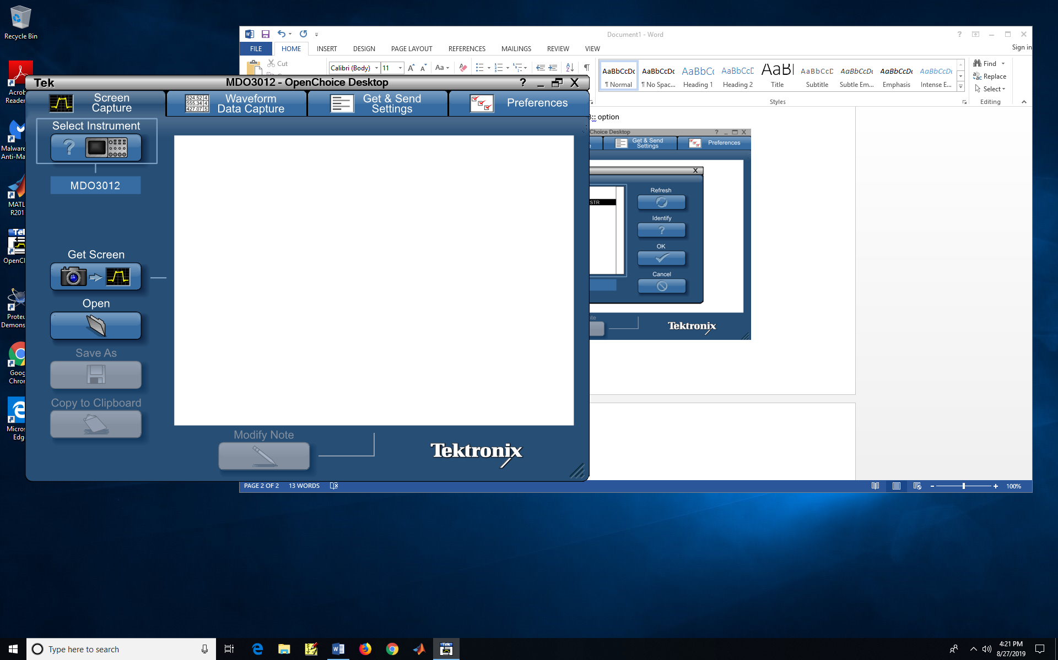

Click Get Screen, then you have oscilloscope display.

