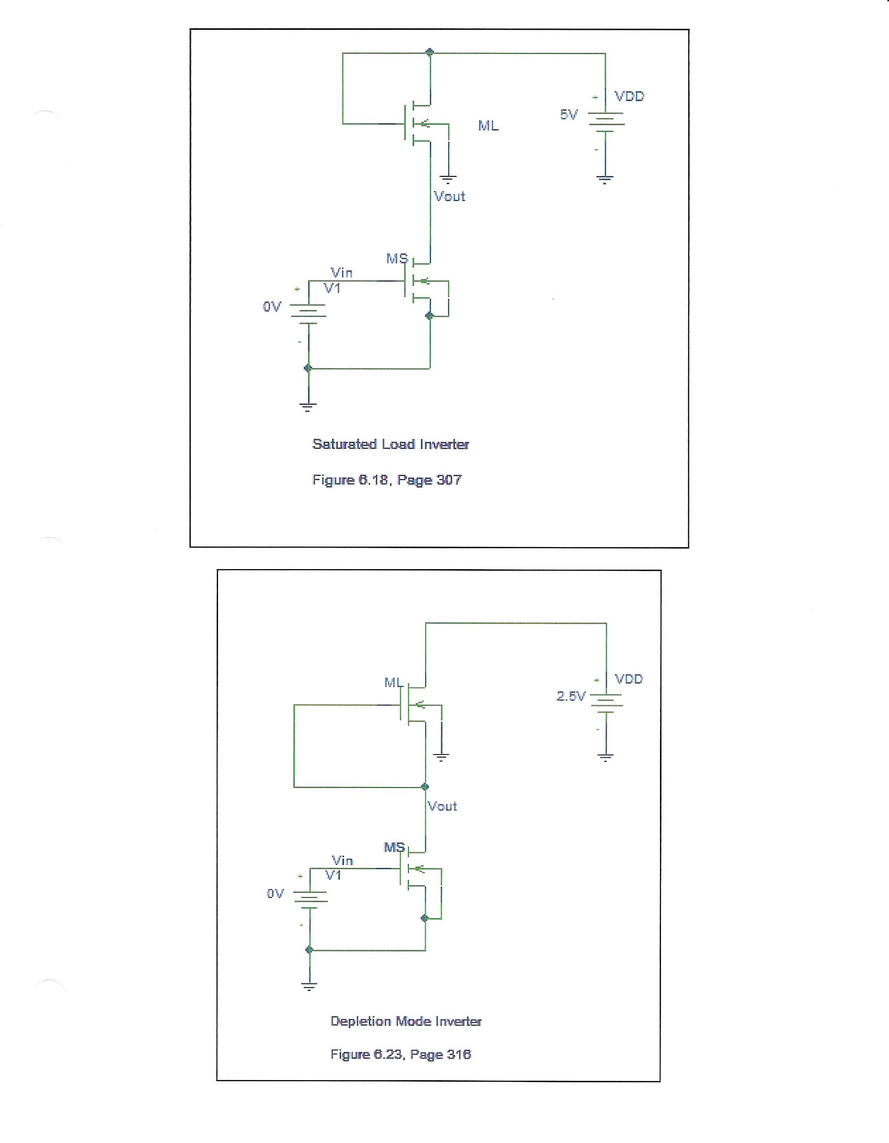
Figure 6.18(a) Page 303

Figure 6.23 Page 312

