ECE 2212
PROBLEM SET 11
Due: FRIDAY, 21 April 2017
S. G. Burns

NOTE 1: I will not collect Problem Set for grading, however you are well-prepared for Quiz 11, Friday 21 April, if you bring your completed Problem Set 11 with you!

NOTE 2: Quiz 11 is scheduled for Friday, 21 April, not a Wednesday, 19 April.

- Text 15.112. Also sketch and label the back-to-back load lines.
- From an old quiz.

Assume a Class B audio amplifier operating between ±48 volts and driving a 4 Ω speaker. Neglect the effect of crossover distortion.
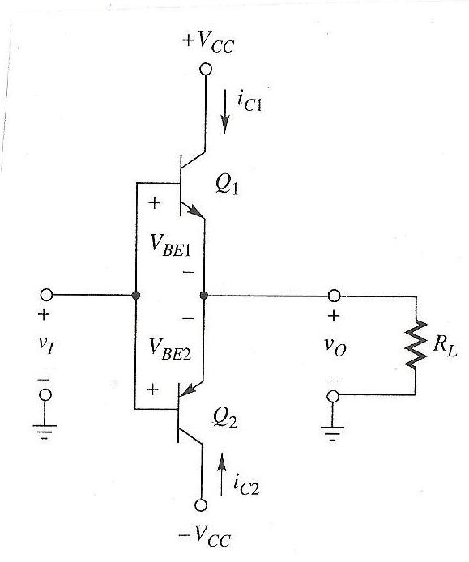
- Provide required maximum ratings as indicated for the transistors using a well-labeled sketch of the back-to-back load lines to illustrate your answers.

I_{C(max)} = ____________ V_{CE(max)} = ___________ P_{C(max)} = __________

- Design a protection circuit to limit the transistor to the I_{C(max)} you computed in part (a) should the amplifier output be short-circuited. Incorporate this protection circuit in your basic Class B circuit diagram.

3. Amplifier Analysis
A partial circuit diagram for a Fujitsu MB 47358 operational amplifier is given below. Assume V⁺ = 15 volts and V⁻ = -15 volts. For the npn transistors, assume β = 150, V_{BE(on)} = 0.7 Volts, and V_{AN} = 100 Volts. For the pnp transistors, assume β = 100, V_{BE(on)} = 0.55 Volts, and V_{AP} = 50 Volts.
(a) Briefly describe the circuit function/operation of :
Q₁₀ and Q₁₁
Q₁₃ and Q₁₄ (Diode connected transistors)
Q₇ Circuit topology
Q₅ and Q₆
(b) Assume a sinusoidal input voltage that results in an output voltage v_{o}(t) = 12 sin (ωt) volts. R_{L} = 1 kΩ.
Compute values for :
- Peak and average power to the load resistor.
- Resultant collector efficiency.
- Power required from the power supplies for the output stage.
- A design value for R_{SC} to limit the short circuited load current to 30 mA .
(c ) Estimate the following :
- Collector currents in Q₅ and Q₆
- Collector currents in Q₁ and Q₂
- Voltage at the base of Q₅ and Q₆
- Voltage at the emitter of Q₇

